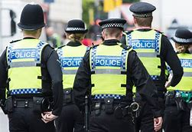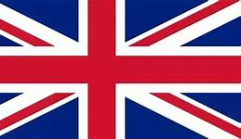 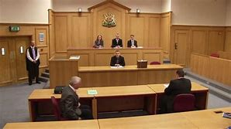 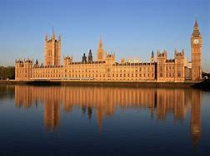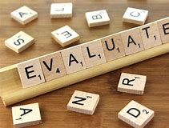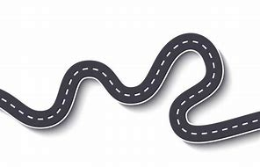

Identity

Role & regulation of the media

International Organisations

**Life in Modern Britain**

World with no laws

Rule of Law

Legal representatives

**Rights & Responsibilities**

Development of UK law

Development of law from outside the UK

Rights & responsibilities of the police

Crown Prosecution Service

Judiciary

Juries

Profile of crime in the UK

Crime in the courts

Sentencing

Youth Justice System

**Exams - Summer – Year 11**

**Politics & Participation**

Democracy

British constitution

Political parties

The role of Parliament

Electoral systems

Members of Parliament

Formation and role of the government

**Start - Autumn - Year 10**

Deciding the question or the issue

Carrying out initial research

Taking the action

Planning the action

**Active Citizenship**

Evaluate the process

Assess the impact of the action

The five British values