Assessment Policy

Date: | January 2021
Date approved by Management Committee: | January 31st 2021
Signature of Chair of Management Committee: | Sue Cain
To be reviewed: | Annually

This policy gives guidance to staff on all aspects of assessment: This includes:-
  - assessment for learning
  - assessment of learning
  - reporting and communication

It should be read alongside the following policies:

- GDPR Policy
- Teaching and Learning Policy
- Feedback and Marking policy
We respect all the personal data we hold on our students and fully embrace both the principles and practice of its protection through GDPR.

Introduction / Aims and Objectives
- Assessment is fundamental to everything we do as it enables us to prioritise, support, extend and challenge in order to create a more bespoke curriculum, improve student learning outcomes and future life chances.
- There is no point in assessment unless it makes a positive difference for the students in our care

Crucial Data Note
- We fully respect all the personal data we hold on our students and fully embrace both the principles and practice of its protection through GDPR. (See full GDPR data map and risk assessment)

Rational for Effective Assessment
Assessment is only effective if;

- It is integrated into the learning process and is valued by all concerned.
- It is both formative (Assessment for learning) and summative (end of term testing).
- There are regular reviews, which are communicated and acted upon at all levels.
- Judgements are constructive and communicated using a proactive approach.
- We compare like with like wherever possible. (E.g. through benchmarking with the Data Pioneer Group)
- It is acknowledged that any assessment has some degree of subjectivity therefore it is important that
  - there is regular robust quality assurance,
  - accountability is itself constructive and embedded in CPD.
  - adaptations are made where needed to ensure the most effective assessment procedures are used consistently.

Baseline Procedure and Quality Assurance
- All students are baseline assessed through a mixture of
  - observation,
  - set 1:1 or group tasks
  - and summative assessments / “Baseline tests”
This baseline is by necessity based on a “working at” not “full coverage” (each student arrives at different times)
- Baseline assessments are made within the first two weeks of arrival.
- Baseline assessments are usually only made in core subjects although in KS4 they can be made in other exam subjects.
- These baselines can be amended by the staff up to 4 weeks into the placement if further evidence comes to light.

- The baselines are based on the Progression Lines using a “Best Fit” model of the skills observed. (See files and below) or another method deemed appropriate by the class teacher
- Students are broadly leveled using the blue headline markers
- They are fine tune leveled using the black descriptors
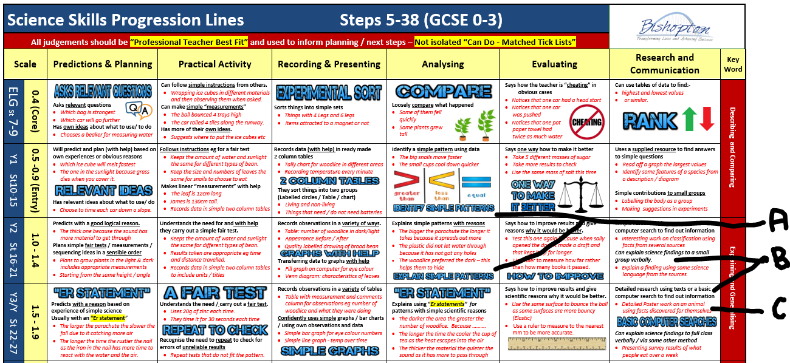
- Judgements can be both quality assured and explained with guidance from the red examples.
Baseline Procedure and Quality Assurance
- Ongoing CPD is provided to support staff in making these judgements and communicating them to all concerned.
- Personal Learning Portfolios are then used to track and display the progress of each child.
- Photographs and examples of work standards will be collected on a regular basis to demonstrate the skills and abilities of each individual child.
- Learning portfolios are group moderated each term and further CPD provided as appropriate.
- Where possible learning portfolios are supported by evidence from each child’s home school to provide an understanding of the child’s prior knowledge, skills and gaps in learning.

Rainbow Bands

The baseline judgements and any available prior data such as KS2 SATS and CATS tests allow us to broadly grade students into one of 9 Rainbow Bands for both current & past performance.

If we look at any of the recent government targets
Eg Meet the early learning goals / Reach 100 in reading at KS2 SATS / Achieve Level 4 at GCSE
- We have children who “excel” (Exceeding - usually the top 25%)
- We have children who "make the standard" (Expected - usually around 75%)
- We have children who are working towards the standard (Emerging – usually the lower 25%)
​
If we further break down these 3 groups we can make 9 Bands

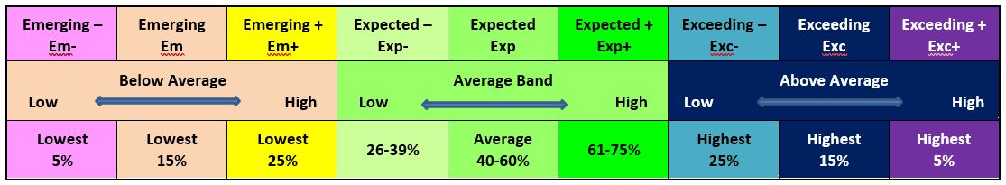

We would expect those in the top 25% in Reception to continue to be in the top 25% in KS1 / KS2 / KS3 and KS4
- Value-added neutral would be that they stay in the colour band.
- Value-added plus would be that they move up a colour band.
- Below "expected" progress would be students who fall down colour bands.
​
The same principles can apply to anything. For some aspects, national data exists and for others there are no benchmarks but teachers instinctively know where the child appears on this measure and their potential for moving up or down.
- Attendance
- Exclusions
- Engagement in learning
- Introverted / Extroverted
- PSHE and SEMH
​
Some caveats on this have to be put in place
- Sample size means that individuals will "buck the trends" for a multitude of reasons.
- Context is everything and a child who was going through tough times in upper primary might do less well at KS2 and have lots more potential to improve.
- The top 5% find it hard to stay at the top so tend to drop back a little on average.
- The lowest 5% tend to move up more often than you might expect as no-one can overtake them but they can overtake others who are struggling at a different time for one reason or another.
- Teacher assessment for learning is often higher than final assessment of learning due to "exam skills" / confidence etc

The Rainbow Grid
This grid provides a visual indicator as to expected flightpaths. (See full sheet)
The expected flight path is that students remain in the colour band from the baseline on entry.
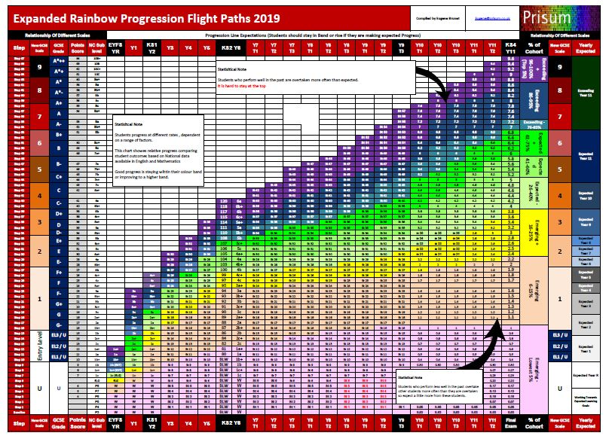 | Minimal Expectations are set so that students should improve their position within the colour band or move up.  Many of the students in alternative provision have fallen down the colour bands for one reason or another.  Therefore more aspirational targets can be set once the support is in place.  These end of year expectations should take account of how long there is to the end of the year / course.  See also Data Pioneer Benchmarks and report for comparison in Alternative Provision.
Assessment For Planning / Assessment For Learning
- The analysis spreadsheet sets minimum expectations based on the rainbow grid. These are then reviewed and where appropriate more aspirational targets are set and shared with the student.

- Using the all available information staff set personal and specific learning targets / expectations for students.
  - Baseline judgements
  - The rainbow grid and expected flightpath
  - Specific learning expectations from the progression lines
  - Examination Board / SATS expectations.

- Staff will work closely with the students to promote learning through:-
- Positive feedback at every opportunity.
- Constructive developmental feedback alongside strategies for improvement.
- Assessment strategies that force students to think and raises aspirations using the tried and tested Assessment For Learning Strategies central to the CPD provided.
- The highest aspirational expectations based on building positive relationships.

- Teachers and classroom support staff are expected to provide written feedback wherever appropriate.
This can take many forms depending on the context but at all times should be positive and constructive.
While at times feedback can highlight all aspects of learning the most focus should be:-
  - To highlight what went well and why.
  - To highlight what might make it even better / how to improve,
  - To focus more on the skills and building self-confidence rather than presentation or facts.

Summative Assessments
In addition to baselines teacher assessments are made on all students in all subjects each term
- Best fit teacher professional judgements are made, using the progression lines and looking at all available evidence.
- This will include learning portfolios, class books, verbal responses and summative assessments (tests).
- Judgements will be made on current students and all those who left the school that term
- Judgements are made as “working at grades” based on areas assessed at the time (Note many students only do 12 weeks)
- Judgements are made as
  - Decimal grades in KS3 Core subjects (E.g. 1.2 represents someone who is working at a Grade 1)
  - KS3 non core subjects will not be included in the data drop with the exception of Art.
  - Decimal grades in KS4 GCSE (E.g. 3.1 represents someone who is just working at Grade 3)
  - Percentage completion for Non GCSE subjects where there is a Pass / Fail
Centralisation of Data
All progress data is collated using the SIMS and exported for analysis
This data is shared with Prisum LTD in order to provide support, challenge and benchmarking.
We share aspects of this data with the Data Pioneer Group coordinated by Prisum LTD. Full GDPR is adhered to at all times.
- A central folder is prepared for use by SLT.
- Appropriate printouts / access to findings are provided for students, staff and line managers to aid them in their roles.
- Individual data sheets and other outputs are used with students and for meetings e.g. Reintegration into mainstream.
Statistical Analysis Of Data
All progress data is converted to “progress points”. Full school data can be distorted by short stay students so for this reason data for all students who have had less than 20 days at the school are not included in full school analysis.

When interpreting the data notice should be given to the full statistical notes accompanying them. This analysis has a prime focus of prioritizing next steps for both students, groups and school Improvement.
Roles / Responsibilities
Lead on Policy: Laura Cooling
Consulted on Policy: Eugene Brunet, Rachel Campbell
Implementation Lead: Laura Cooling on Data & Tracking
Emily Carr and Rachel Campbell on teaching, learning and curriculum
Monitoring and Evaluation
The prime objective of all data collated in this way is to support learning and progress.

A report is regularly produced for governors who then review both the outcomes and process.
Staff must be free to make accurate and informative judgements and then act on them in the best interest of the students.

Robust challenge is part of this process – however the vision of our school is that this is undertaken as part of the natural evaluative cycle that prioritises support and next steps for the young people in our care and the work we undertake
- A random 10% sample of the judgements are group moderated each term and further CPD provided as appropriate.
- Judgements that are significantly different from previous records are moderated via discussion with the line manager
- Line managers will quality assure the judgements via line management meetings using the automated printouts available via the analysis spreadsheets.

UN Convention of the Rights of the Child (UNCRC)

The Bishopton Centre is a Rights Respecting School. Based on the principles of equality, dignity, respect, non-discrimination and participation. It places the rights of the child at the heart of everything it does including school policy and strategic planning. Our school community ensures that rights are learned, taught, practiced, respected, protected and promoted. There are 54 articles in the UNCRC, (for a copy of these please ask the Rights Respecting Steering Group Chair) the following articles specifically underpin this policy:

Article: | Summary:
1 | Definition of a child
3 | Best interests of a child
5 | Parental guidance and a child’s evolving capacities
6 | Life, survival and development
8 | Protection and preservation of identity
9 | Separation from parents
11 | Abduction and non-return of children
12 | Respect for the views of the child
13 | Freedom of expression
14 | Freedom of thought, belief and religion
15 | Freedom of association
16 | Right to privacy
17 | Access to information from the media
19 | Protection from violence, abuse and neglect
31 | Leisure, play and culture
34 | Sexual exploitation
35 | Abduction, sale and trafficking
36 | Other forms of exploitation
37 | Inhumane treatment and detention
38 | War and armed conflicts
40 | Juvenile justice
41 | Respect for higher national standards
42 | Knowledge of the rights of a child

