Fire Evacuation Plan

Date: | January 2021
Date approved by Management Committee: | January 31st 2021
Signature of Chair of Management Committee: | Sue Cain
To be reviewed: | Annually

Introduction

Fire Safety Housekeeping

Fire doors are designed to prevent the spread of fire and poisonous smoke, and to provide people with protected routes to safety in the event of fire. Here are some housekeeping rules staff and visitors must follow:
- Do not wedge fire doors open, or store combustible materials in corridors and stairs as it is also an offence.
- Staff and visitors must familiarise themselves with the location of all fire exits, fire alarm call-points, fire extinguishers and the fire assembly point.
- This is a non-smoking building – smoking is not permitted anywhere on the premises.

Discovering a fire – what you must do:
- Raise the alarm - shout fire, fire, fire! And operate the nearest fire alarm call-point to warn everyone in the building that there is a fire.
- If you suspect a fire, sound the alarm. Do not search for the seat of the fire.
- Only the fire brigade should do that - particularly where this involves opening doors when a fire is suspected to be behind them.
- If there is smoke in the corridor etc; then you have already found the fire and it is already time to raise the alarm!

How to Sound the Fire Alarm using the Key Provided
- Insert Key
- Turn 90 degrees clockwise and fire alarm will sound
- As soon as fire alarm has sounded leave building immediately

Call the Fire Brigade
Do not delay in summoning the fire brigade. Call from a place of safety. Dial 9999 from internal phones or 999 from external phones.
Please alert staff over radios that there is an actual fire. Telephones are located in every office.
Sound the alarm first & call the fire brigade
Keep your escape route clear
Use the correct type of extinguisher.

Evacuation Procedure (on hearing the fire alarm)

When you hear the alarm staff, pupils and visitors must do the following:
- Leave the building promptly, do not wait to be told and do not attempt to collect personal belongings.
- Close doors and windows behind you if time permits and only where you can.
- Observe any specific instructions about isolating equipment or services.
- Use your nearest fire exit, (look for the green ‘running-man’ signs).
- If you find smoke blocking your route then go a different way.
- Do not block the fire exits.
- Move away from the building and keep the entrances clear for the fire brigade.
- Once out of the building proceed to the fire assembly point and listen to the instructions given by the fire warden/s, who is responsible for your safety and liaising with the fire brigade.
- Do not go back into the building until you are specifically told to do so by the fire warden/s or the attending fire brigade officer in-charge.

Note: silencing the alarms is not a signal to re-enter the building.

Helping visitors and others that you may encounter:
- Fire wardens, wearing high visibility armbands are there to help and ensure the building is evacuated; you must carry out any -63
- Do escort out your visitors, members of the public etc.
- Do assist anyone with mobility difficulties.
- Disabled staff and visitors will have a personal emergency evacuation plan.
- Take the needs of mobility impaired visitors into account at their point of entry (disabled, blind, deaf etc.)

Fire Assembly Point:

See Appendix 1 & 2

Pictorial Evacuation Assembly Points
Assembly Area Appendix 1
(Good Weather External Evacuation)

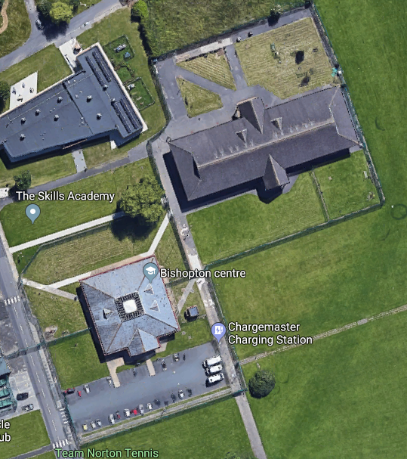
Vehicle Gate
Perimeter Fence
Key Controlled Gate

Key Controlled Final Exit
Redhill Assembly Point

External Evacuation Route
Bishopton Assembly Point

Pictorial Evacuation Assembly Points
Assembly Area Appendix 2
(Adverse Weather Internal Evacuation)

Vehicle Gate
Perimeter Fence
Pedestrian Gate
Key Controlled Final Exit

Bishopton Assembly Point (Within building)

Redhill Assembly Point (Within building)

The conduct of people at the Fire Assembly Points and on leaving the building is critical to everyone’s safety

Fire Wardens:

The Chief Fire Warden will take overall charge of the situation until the arrival of the fire brigade (if they are required). This will be the most senior person in charge at the time.

The Fire Wardens are responsible for ensuring ALL parts of the building are evacuated.

All staff have been designated as Fire Wardens

Once they have cleared their designated areas they should report to the Chief Fire Wardens over radio and make way to the evacuation point.

Emergency Exit Routes:

- In the event of the fire alarm sounding, leave the building by the nearest exit.
- All Fobbed controlled doors and fire doors will automatically UNLOCK, and alarmed doors de-activate, when the fire alarm sounds
- Notes to help interpret the plans:
- Emergency exit routes are illustrated using red arrows that show the route that should be followed from each floor / space: These are in each room of the centre.
- Fire Points (FPs) are shown by the symbol:

Fire Alarm System

The Alarm is tested by on site staff and serviced by a competent contractor as detailed in the Fire Log Book

