Careers Education, Information, Advice and Guidance (CEIAG) Policy

Date: | January 2021
Date approved by Management Committee: | January 31st 2021
Signature of Chair of Management Committee | Sue Cain
To be reviewed: | Annually

This policy articulates Bishopton’s Careers Educational Information Advice and Guidance. This policy should be read in conjunction with the PSHE, SMSC, Teaching and Learning, Equal Opportunities and British Values policies.
Introduction

Bishopton has a statutory duty of care to secure independent careers guidance for all year 7 to 11 pupils (Education Act 2011/Careers Guidance and Access for Education and Training Providers 2018). Using the Gatsby Benchmarks we believe every child should leave school prepared for life in an ever changing modern society. We therefore provide academic rigour supported by quality teaching and learning to develop every young person’s values, skills and behaviours that they will need to progress and succeed in all aspects of life. Our vision is as follows:

“We believe every child should leave our school prepared for life in an ever changing modern society. We therefore provide the academic rigour supported by quality teaching and learning to develop every young person’s values, skills and behaviours that they will need to progress and succeed in all aspects of life”

The statutory duty requires schools to ensure that all registered pupils at the school are provided with independent* careers guidance.
This advice is:

- Presented in an impartial* manner
- Includes information on the range of education or training options, including apprenticeships and other vocational pathways
- The guidance given promote the best interests of the pupils to whom it is given.
*Independent is defined as external to the school.
* Impartial is defined as showing no bias or favouritism towards a particular education or work option.

Aims of CEIAG (Careers Education, Information, Advice and Guidance)
- Provide good quality independent careers advice to pupils which inspires and motivates them to fulfil their potential;
- Provide personal advice and guidance which is in the best interests of, and meets the needs of all pupils;
- Be based on the Gatsby Benchmarks for Good Careers Guidance;
- Contribute to raising of pupil achievement by encouraging pupils to develop high aspirations and consider a broad and ambitious range of careers;
- Provide opportunities to work in partnership with employers, training providers, local colleges and others;
- Provide opportunities to inspire pupils through real-life contact with the world of work;
- Develop enterprise and employability skills including skills for self-employment;
- Support inclusion, challenge stereotyping and promote equality of opportunity;
- Encourage pupils to see career development as a life-long process;
- Develop pupils’ skills and knowledge of careers including career management skills and knowledge of the local labour market (Local Labour Market Information LMI);
- Ensure pupils are aware of the full range of academic and technical routes available at each transition point so that pupils have the necessary knowledge to make successful transitions;
- Provide opportunities for meaningful encounters with employees, employers, further and higher education and experiences of workplaces;
- Support social mobility by improving opportunities for all pupils, especially those from disadvantaged backgrounds and those with special educational needs and/or disabilities;
- Be embedded into subjects across the curriculum including PSHE
Commitment
Career guidance can include employers talks, inspirational speakers, mentoring, talks from colleges and other further educational establishments, apprenticeship providers and universities as well as access to online information. External speakers are coordinated by the Careers Lead in Bishopton and supported by key members of staff.
Independent advice & guidance in Bishopton is currently offered through Youth Directions who begin working with our pupils from year 7. The advisers are suitably qualified and bound by the CDI code of ethics. It is presented in an impartial manner, showing no favouritism towards a particular industry, provider or institution. The guidance covers a full range of post 16 options and is pupil focused based in their needs, wants and aspirations.
Bishopton is committed to providing a stable and structured programme of education, advice and guidance. Based on the Gatsby Benchmarks for Good Career Guidance this is differentiated to suit the needs of each pupil. Bishopton Career Programme can be found in Appendix A.
Each pupil is entitled to:
- Independent and impartial careers guidance
- Access to external sources of information on the full range of education and training options
- A stable programme of advice and guidance delivered by individuals with appropriate skills, experience and qualifications
- Opportunities to engage with a range of employers, education and training providers, covering the full range of academic and technical routes available at each transition point
- At least one meaningful encounter with an employee or employer each academic year
- Have access to good quality LMI and be supported to use this data to inform their decisions
- At least one careers interview by the age of 16 with a Careers Adviser
- At least one experience of a workplace by the age of 16
Bishopton has been recognised as delivering good quality CEAIG and has achieved the Quality in Careers Standard in December 2017 and remains committed to keeping that quality mark in December 2020.
Curriculum
Key Stage 3 Provision:
- Subject areas promoting careers within curriculum areas
- Access to impartial advice and guidance sessions with Youth Directions
- Access to online packages
- External visits
- Internal talks
- CASTLE Days – Aspirations and Self-Belief
- Access to careers and IAG enrichment and extra-curricular activities and events
- Careers Events
By the end of KS3 pupils will have:
- A better understanding of their strengths, achievements and areas for development
- A better understanding of the full range of 14 – 19 opportunities for progression
- An understanding of the qualities, attitudes and skills needed for employability
- Used online careers resources to research opportunities included to support them with KS4 options.
Key Stage 4 Provision:
- Subject areas promoting careers within curriculum areas
- Tutor time
- PSHE – Living in the Wider World (Careers and Work and Personal Finance) summer 1 & 2
- Access to a Work Experience opportunity
- Apprenticeship Awareness talk
- Access to impartial advice and guidance sessions with Youth Directions
- Access to online packages e.g. National Careers Service and KUDOS
- External visits
- Internal talks
- CASTLE Days – Aspirations and Self-Belief
- Access to careers and IAG enrichment and extra-curricular activities and events
- Careers Events
By the end of KS4 pupils will have:
- Enhanced their career management and employability skills
- Used online packages and other sources of information, advice and guidance to investigate and explore progression routes
- The opportunity to experience the world of work through work experience and workplace visits.
- Be given direct access to employers, colleges and training providers
- Be given independent impartial external one to one advice on post 16 destinations
- Developed an Employability Folder which includes a CV, personal statement and evidence of a mock interview with feedback.
- Produce a challenging but realistic plan by relating their abilities, attributes and achievements to the goals they have set themselves.
External Partnerships
Bishopton works effectively with a range of external stakeholders including vocational provision and has developed a number of partners to offer:
- Careers events
- Work Experience
- Career talks
- Mentoring
- Workplace visits
- Visits to FE and HE institutions
- Apprenticeship visits and talks
- Inspirational Speakers
- Enterprise activities
Bishopton provides opportunities for informing pupils about technical educational qualifications or apprenticeships and has a published statement setting out arrangements for provider access.
Bishopton actively promoted parent/carer involvement through CEIAG events, new letters, the website and consultation evenings. The school have also invested in SchoolZone as another way to promote effective communication and encourage parental involvement.
Equal Opportunities
In support of the school’s Equal Opportunities Policy the careers education and guidance will ensure that:
- Lessons cover Equality of Opportunity.
- Carefully selected non biased or stereotypical posters and other media material.
- Pupils are encouraged to prepare to support themselves financially.
- Pupils are encouraged to consider all options including non-traditional careers/roles.
- There is an avoidance of the use of gender and gender specific job titles.
- Offer as free a choice as possible for Extended Work Experience.
- Boys and girls have equal opportunities to speak, offer opinions and answer questions in lessons.
- All pupils have equal access to information.

School Website
The school has a Careers page on its website which has a number of links to organisations that can offer impartial advice and support with a range of different areas e.g. interview techniques, CV writing and online training to support young people into making choices. Parents and carers will be encouraged to access this webpage to support their child and perhaps find some useful information themselves.
CPD
Training needs are identified through Performance Management and through CEAIG based audits of need. CPD is offered to relevant staff as they arise. Information from CPD sessions are disseminated to staff through weekly team meetings. Staff attend networking events locally and nationally.
Responsibility for promoting the highest quality learning environment and creating impressive displays lies with the whole school community. It requires professionalism (based on Teachers Standards and Performance Management) from teachers and staff in the school and in return expects learners to understand the part they play in the process so that they can take responsibility for their own learning.
Roles & Responsibilities
All Bishopton staff have a responsibility for CEIAG through their roles within the school.
Key roles and responsibilities include:
- The Management Committee in defining and agreeing the principles underlying the school policy and in monitoring and reviewing its application. The Management Committee Lead for Careers is ??;
- The Head teacher in framing the school policy and, with other members of the Senior Leadership Team, organising support for the implementation of the policy and the monitoring of the school environment;
- The Careers Lead (Marie Clay) and Careers Team in ensuring the provision for CEIAG is well planned and delivered and monitored.
- Teachers in observing the Teachers Standards and ensuring they are fulfilling their professional roles and responsibilities;
- All staff in ensuring consistent application of the policy.
Monitoring and Evaluation
- Bishopton’s progress towards the Gatsby Benchmarks is evaluated using the online Compass Tool this is carried out on a termly basis and informs the CEIAG Strategic Action Plan.
- Feedback from pupils and all key stakeholders are obtained and subject to scrutiny, they are analysed by the careers lead with actions fed back to whole school in team meetings.
- External provision is monitored and evaluated through the Bishopton’s Quality Assurance Framework and includes pupil voice, this is fed back every 6 weeks to the Head teacher via an Analysis Document.
- The effectiveness of Bishopton’s CEIAG if reflected in the number of pupils who successfully transition into post 16 destinations and remain in education, training and or employment including self-employment. Destination Data is collated approx. every 6 weeks and tracks the past 3 years leavers, this is fed back to the Head teacher and Management Committee.
- The Partnership Agreement with Youth Direction is reviewed termly and Youth Direction provide 6 weekly reports and updates regarding pupils.
- Quality of teaching, learning and assessment is monitored as part of the school’s internal Quality Assurance Framework undertaken by the Head Teacher, Deputy Head and on occasion School Improvement colleagues from the Local Authority.
- When reviewing the programme, the School Development Plan is used to ensure that the CEIAG is fully supporting whole school vision, ethos, values and objectives.
- CEIAG policy is reviewed annually and ratified by the Management Committee.
UNICEF - UNCRC
The UN Convention of the Rights of the Child sets out human rights of every person under 18 and applies to every child without discrimination, whatever their ethnicity, gender, religion, language, abilities or any other status, whatever they think or say, whatever their family background (Article 2).
Articles directly relating to this policy are:
Article 2 (Non-discrimination)
Article 12 (Respect the views of the child)
Article 13 (Freedom of expression)
Article 17 (Access to information from the media)
Article 28 (Right to education)
Article 29 (Goals of education)
Article 31 (Leisure, play and culture)

Core Careers Programme
Appendix A

KS3 | Pupils will begin to consider future career paths and what skills may be needed for setting goals, identifying personal strengths and building resilience  Pupils will develop self-awareness and skills discovering what skills are matched with what careers through dedicated Careers lessons and school events  Pupils will recognise and discuss aspects of the world of work in general and personal to their own aspirations and goals:  Work experience  Further education fair  Youth Direction one to one impartial IAG sessions  Inspirational speakers
KS4 | Pupils will explore their potential through a personalised experience based on their interests ,skills and aspirations  Enterprise project delivered through COPE  Work Experience  Alternative Provision  Youth Direction one to one impartial IAG sessions.  Mock interviews  Employer talks  Job searching skills  Apprenticeship provider visits  Post 16 preparation  College and university visits

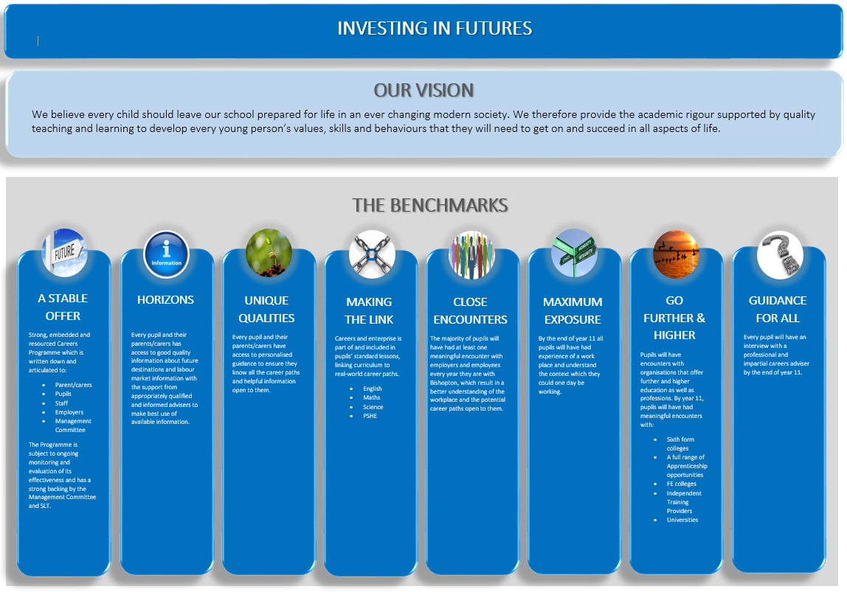
Appendix B

