

One to One and Home Tuition Policy

Date: | January 2021
Date approved by Management Committee: | January 31st 2021
Signature of Chair of Management Committee: | Sue Cain
To be reviewed: | Annually

This policy gives guidance on one to one Home Tuition provision and should be read alongside Safeguarding, Child Protection and Teaching and Learning Policies.

Introduction

Staff at Bishopton recognise that all children and young people are entitled to an education of a high quality and are committed to ensuring that the needs of the most vulnerable groups of learners are met. One to One and home tuition is taking place on a regular basis across our school. The impact of One to One tuition is significant in terms of the increase in tutored pupils’ attainment and also in elements of their life that are harder to measure such as confidence, improved parental relationships, and a change in attitude to learning and themselves.

Aims

All students should have their educational needs identified and receive the appropriate educational support they require as soon as possible. Bishopton is flexible and sensitive to the changing needs of pupils and One to One tuition is an effective method of minimising the interruption and disruption to those pupils who are particularly vulnerable or hard to reach, in order that they continue to have access to as much education as possible, so that they are able to maintain the continuity of their education.

Types of One to One/Home Tuition

Bishopton can provide one to one tuition in the following circumstances:

- Home tuition to pupils with medical needs which prevent them from accessing mainstream education.
- One to One tuition to pupils whose behaviour is becoming a risk to themselves, other pupils or school property.
- One to One tuition to pupils who are working in Alternative Provision or an offsite venue and require Maths and English intervention (and any other subjects required).
- One to One tuition who require intervention in the school building.

Principles

Any members of staff who work outside of school with students must ensure that they are clear of the procedures in place to protect themselves and the students they are working with.

- Tutors should be seen to be working in an open and transparent way.
- Tutors should always act, in the child’s best interests.
- Tutors should focus on ensuring that pupils’ work is of a good standard and that they are remaining on track particularly in their core subjects.

Confidentiality

Tutors should be clear about what information about a student can be shared and in what circumstances it is appropriate to do so. Please refer to Bishopton’s Child Protection Policy for more details. Tutors should always seek advice from a senior member of staff if they are in doubt.

Propriety and Behaviour

Tutors must follow any codes of conduct deemed suitable by their organisation. All tutors should wear suitable attire which would convey their professionalism.

- Tutors should wear clothing that is appropriate to their role, which is not seen as offensive, revealing or sexually provocative.
- Tutors should be vigilant in maintaining their privacy and mindful of the need to avoid placing themselves in a vulnerable situation.
- Tutors should not administer medication – the parent/ carer should do this if necessary.
- Tutors should only deliver tuition if another adult is also in the home.
- Personal mobile phones should not be used whilst teaching or in the presence of a pupil or their family members.

Part –time Timetable Consent Forms

Before a pupil receives One to One tuition it is imperative that we receive a completed and signed consent from (see Appendix C) this form specifies the proposed timetable with days and times made explicit. It also identifies a review date. Completed forms will be uploaded to CPOMS prior to the commencement of One to One tuition.

Communication

- Tutors should comply with the Acceptable Use Document of the Online Safety Policy.
- Tutors should not give out their personal phone number or email address to students including personal mobile phones.
- Tutors should not use the internet or web-based communications to send personal messages to a student.
- Tutors should have no secret social contact with students or their parents.
- Tutors should be aware of Health and Safety Regulations.

Home tuition

- Tutors should record any initial home visit with office staff and ring the office before and after the visit is completed.
- Tutors should ensure that any cause for concern is discussed with senior management and that safeguarding procedures are followed.
- Tutors should never enter a house to tutor a child without the presence of parent/carer or other responsible adult who has been agreed with parent/carers (must be age 18+).
- Tutors should ensure that when lone working they have their IDENTICOM device switched on.
- Tutors should work in open areas of the home where the doors are left open.
- Parents/carers must remain as a visible presence at home and be available for the duration of the tuition.
- Always keep discussions on a professional level.
- If at any point during tuition the tutor feels uncomfortable about any behaviour from the pupil or parent/carer they should end the session and leave the setting. The circumstances should be reported to a senior member of staff as soon as possible.

Tutors should:

- Remain in the designated room of the home for the tuition session (not a bedroom).
- Ensure there is plenty of light.
- Keep a clear focus on the work undertaken.
- Tutors should have clear planning for the work to be undertaken by the pupil.
- Always communicate any times where the pupil becomes upset or distressed with the pupil’s parent/carer.
- Always report any situation where a pupil becomes upset or distressed or behaves. inappropriately to a senior leader at the school.

Other venues

If it is thought necessary, tuition can take place in a nearby library or public building rather than the pupil’s home. All of the above guidelines apply but in addition ensure the venue is suitable for tuition, there is a table and chairs available and the type of building does not in itself pose a risk to the child or the tutor.

Arrangements for meeting and dismissing the child should be agreed with parent/ carer before the tuition takes place. Transportation of an individual pupil should be avoided however the individual needs of the pupil should be taken into consideration. If deemed necessary, it should take into account any relevant risk assessment and prevailing circumstances.

Health and Safety

The very nature of one to one tuition lends itself to potential risks. Tutors should take every reasonable step to eliminate potential risks to increase safety and confidence. They need to make sure they are aware and have a copy of the individual pupil’s risk assessment (see Appendix B). This is particularly important where there are known risk around Domestic Violence, Drug and Alcohol use and offending behaviour. A risk assessment of the location of One to One tuition will also be carried out (see Appendix A) prior to the commencement of tuition.

In order to preserve the safety of our One to One tutors, they are issued with personal IDENTICOM devices and given training in their use. Should the need arise they are able to contact help through the device and the call station. The call station is then able to contact the emergency services and make an audio recording of the events as they happen. It is the responsibility of the individual tutor to ensure that they sign the devices out and wear them at all times. Training will be refreshed annually.

Roles and Responsibilities

It is everyone’s responsibility to ensure that both staff delivering and pupils receiving one to one tuition for whatever reason are free from risk of harm.

Key roles and responsibilities include:

- The Management Committee in defining and agreeing the principles underlying the school policy and in monitoring and reviewing its application.
- The Head teacher in framing the school policy and, with other members of the Senior Leadership Team, organising support for the implementation of the policy and the monitoring of the progress pupils receiving one to one/home tuition make.
- One to one tutors in ensuring that they read and understand information regarding each pupil including individual Pupil Risk Assessments prior to delivering any one to one teaching. That they complete any necessary Risk Assessments on arrival at any one to one teaching venue, that they sign out and wear the IDENTICOM device and report back any concerns they may have about pupils’ behaviour and welfare to SLT.
- Parents/Carers must ensure that their child is out of bed, dressed appropriately and ready to learn before the one to one tutor arrives, that they provide a space free from noise and distraction, that they or another responsible adult is on site at all times and there are no mobile phones or other transmitting devices in the area where teaching takes place.
- Pupils must be ready to learn and must treat one to one tutors with respect and dignity at all times.

Monitoring and Evaluation

The Senior Leadership Team will regularly monitor and review the use of one to one tuition to ensure that it is meeting the needs of the pupils who require it. One to one tutors will be subject to Teaching, Learning and Assessment Triangulation to ensure that they are delivering quality teaching, learning and assessment. Feedback will also be obtained and reviewed from both pupils and parents and carers as part of this process (see Appendices D&E).

UNICEF - UNCRC

The UN Convention of the Rights of the Child sets out human rights of every person under 18 years old and applies to every child without discrimination, whatever their ethnicity, gender, religion, language, abilities or any other status, whatever they think or say, whatever their family background (Article 2)

Articles which directly relate to this policy are:
Article 2 (Non-discrimination)
Article 28 (Right to education)
Article 29 (Goals of education)

APPENDIX A


HOME VISITING RISK ASSESSMENT

Name of pupil:
Address of pupil:
Contact details:
Name of person completing Risk Assessment:
Date completed:
OBSERVATIONS |  |  |  | YES |  | NO
Have any risks been identified by any other agency?
Are the entrances/exits to the property easily accessible?
Are there any dangers/hazards associated with the property?
Are you aware of any intimidating/threatening clients, relatives or friends living at or likely to visit the property?
Are there pets in the household?
If yes to the above, are they threatening?
Are you confident all safety measures are in place?
Do any members of the household smoke?
If yes to the above, have you discussed the Bishopton’s smoking policy?
Is there safe and accessible parking?
Is there a basic standard of hygiene?
AREAS OF CONCERN
ACTION(S) TO ELIMATE/REDUCE RISK? |  |  |  |  |  | BY WHOM
Staff Signature: |  |  | Date:

APPENDIX B

Individual Pupil Risk Assessment

Name of child/young person: |  | Name of person completing the form:
Organisation: |  | Date of completion:
Please complete the table below giving as much detail as possible. Please consider the likelihood of occurrence (L.o.O) using the score rating below:
1 = Very remote
2 = Improbable
3 = Possible
4 = Probable
5 = Likely
6 = Certainty

Risk Indicator | Y/N | Details (Inc. triggers & recommendations) | L.o.O
History of absconding from placement?
History of verbal aggression towards staff?
History of verbal aggression towards peers?
History of physical aggression towards staff?
History of physical aggression towards peers?
History of damage to property?
History of fire setting?
History of self-harm?
History of sexualised behaviour?
History of causing distress to animals?
History of causing distress to younger children?
History of carrying and/or using weapons?
History of bullying?
History of being bullied?
History of offending behaviour?
History of stealing?
History of alcohol abuse?
History of substance misuse?
Vulnerability towards becoming radicalised, or hold extremist views?
Any other info deemed relevant?
Can you foresee any issues with their behaviour in a car or bus?
History of making allegations against staff?
Any other comments you think are important?
APPENDIX C

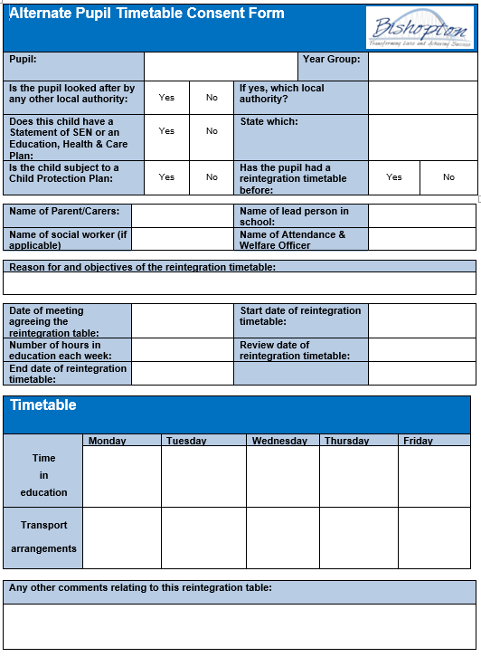

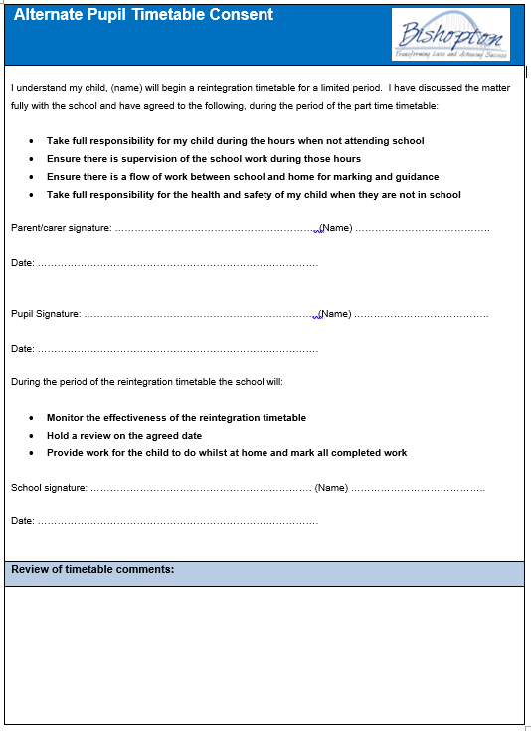
Monitoring Learning 1-1 Parent/Carer Survey |  |  |  |  |  |  | 
Date | My Child
Date | 1-1 Tutor |  | Year Group | Gender (M/F)
July 2016
Leave any questions  that do not apply |  |  | Please tick the box you most agree with.
 |  |  | Strongly Agree |  | Agree | Disagree |  | Strongly Disagree
I believe my child enjoys the learning sessions with the 1-1 tutor
The tutor expects my child to do their best.
I can talk to the tutor if I am worried about any issues concerning my child
The tutor sets behaviour boundaries and has clear expectations for my child
The tutor tells me when my child has made progress
The tutor keeps me informed on my child’s achievement and next steps
The tutor sets homework for my child
The school talks to my child about the next steps for their future
What do we do well and what can we do to improve things?
It is good because …
It would be even better if…
Any questions?
APPENDIX D
APPENDIX E
Monitoring Learning 1-1 Student Survey
Date | About Me
Date | 1-1 Tutor |  | Year Group | Gender (M/F)
Leave any questions  that do not apply |  |  | Please tick the box you most agree with.
 |  |  | Strongly Agree |  | Agree | Disagree |  | Strongly Disagree
I enjoy learning sessions with the 1-1 tutor.
The tutor expects me to do my best.
I can talk to the tutor if I am worried about any issues.
The tutor expects my behaviour to be good.
The tutor praises me when I do good work.
The tutor sets me targets so I know my next steps to learn.
The tutor tells me how to improve my work.
The tutor regularly sets me homework.
Staff ask me what I would like to do when I leave school.
What do we do well and what can we do to improve things?
It is good because …
It would be even better if…
What I plan to do when I leave school…

