Positive Handling Policy

Date: | January 2021
Date approved by Management Committee:

Signature of Chair of Management Committee: | Sue Cain
To be reviewed: | Annually

This policy should be read in conjunction with:

- Behaviour and Relationship Policy
- Safeguarding Policy
- Child Protection Policy

Rationale

As a pupil referral unit our mission is to offer children and young people who have been excluded from mainstream school, or who are at risk of exclusion, a range of positive, stimulating and supportive, alternative learning solutions based on their individual needs. This policy acknowledges and respects this great diversity of needs.

Bishopton PRU seeks to provide a personalised educational experience that identifies and responds to the circumstances and needs of each individual young person. We work within a framework of equal opportunities, stability and security, so that our pupils at the Bishopton Centre, are encouraged and challenged to develop academically, emotionally, personally and socially in preparation for the next stage in their education. In doing so will enable every individual to fulfil their potential and become successful young people

As a centre, we have chosen to ensure staff are trained and are using the Team Teach approach for de-escalation and positive handling. Our training leads us always to proceed, in any potentially hazardous situation, with the needs of the whole child at the heart of all our actions. It is important that we remember that all behaviours are a product of each individual’s feelings which in turn arise from experiences.
‘Fairness involves treating everyone differently and not the same’

We will therefore use the minimum intervention compatible with maintaining the safety of individuals and the good order of the school as a whole. Following any use of restraint we will conduct a review of events and seek to learn lessons in order, constantly, to improve our practice and our provision.

This document draws together the recent guidelines and legislation regarding school behaviour and discipline as well as the core principles of Team Teach;

- Section 550a, Education Act 1996;
- DCSF Circular 10/98;
- Criminal Law Act 1966;
- Crime and Disorder Act 1998;
- Human Rights Act;
- Health and Safety Legislation;
- Race Relations (Amendment) Act 2000.
- DfE Use of force guidance 7/11

Aims

At Bishopton, we aim

- To ensure that our services reach out to the socially disadvantaged and those who experience discrimination.
- To uphold a high standard of behaviour with mutual respect between all members of the school community.
- To promote self-discipline and acceptance of responsibility for our own actions.
- To maintain a positive and safe school climate where effective learning can take place and pupils make progress to the best of their ability.
- To reflect diversity as an employer and as a service provider in all areas of our activity.
- To ensure that, where pupils present the most challenging and potentially dangerous behaviour, we will treat them at all times with dignity, compassion and humanity, protecting their rights and maintaining privacy and protection from the possible criticism of others.
- To act professionally to keep individuals and groups safe from harm. This will apply to adults and pupils alike.

Bishopton Expectations

Here at Bishopton, we have a duty to promote good behaviour and discipline. The school governing body, with the support of the County Council, has the duty to ensure the health, safety and wellbeing of everyone in school. The purpose of this policy is to ensure Bishopton staff understand and implement expectations regarding school discipline and to support the leadership of the school, including the Management Committee, to comply with legal requirements that are now placed on them and to exercise those powers within the legal framework.

For some pupils with the most significant needs, it must be recognised that their challenging behaviour is an aspect of their developmental profile. Interventions to manage their behaviour must reflect their overall needs, should be matched to their particular circumstances and also be in the interests of the school as a whole. It is essential that staff act appropriately in order to minimise the risk of accusation of improper conduct towards a young person.

Legislation that came into force on 1 September 1998 (Section 550a of the Education Act 1996), together with national guidance (DCSF Circular 10/98) established the responsibility of teachers and other authorised staff who have lawful control or charge of pupils with regard to the application of reasonable force in order to prevent children committing an offence, causing injury or damage, or engaging in behaviour prejudicial to the maintenance of good order and discipline.

Further guidance was issued and the above updated by the DfE in July 2011 The equality act 2010 states, schools have a general duty to promote equality. This policy was constructed in order to be compatible with this duty and staff will act at all times to ensure that they do not discriminate in any way.

Reasonable force or restraint is only to be used as a last resort. The Education Act 1997 clarified the position about the use of restraint by authorised school staff when managing the behaviour of the most challenging pupils in our schools. This has been updated by DfE Use of force guidance 7/11

At Bishopton, the use of any restrictive physical interventions should always be considered within the wider context of other measures available to staff. We prioritise establishing and maintaining good relationships with students and using diversion, diffusion and negotiation to respond to difficult situations.

It is an expectation at our school, that staff are aware of the national guidance and act responsibility within it. All staff will be updated on national guidance, de-escalation and positive handling through the Team Teach course and refresher courses offered within the period of renewal if not before.

Bishopton will hold a central database of all staff trained, the certificate number and the date of renewal. It will also be an expectation for all staff to have read the Positive Handing Policy and Positive Behaviour Policy as well as DfE Use of force guidance 7/11.

Key Definitions

Restrictive Physical Intervention (RPI): “the use of force to control a person’s behaviour” DOH / DFES R.P.I July 2002). It involves the use of force to:

- Restrict movement
- Restrict mobility
- Disengage from dangerous or harmful physical contact

Reasonable Force: outlines that the degree of force should be in proportion to the circumstances and the seriousness of the behaviour or consequences it is intended to prevent. The level and duration of the force used should be the minimum necessary to achieve the desired result, such as to restore safety. Key words staff should be mindful of when using force are reasonable, proportionate and necessary.

Positive Handling: describes a holistic approach to a range of risk reduction strategies which may include: non-verbal, verbal and where ‘reasonable and necessary’, physical restraint
Positive Handling Plan: the agreed strategies (non-verbal, verbal and physical) that aim to support the individual, providing them with a sense of security, safety and acceptance, allowing for recovery and repair, facilitating learning and growth.

Prompt: any form of touch that re-directs or prompts them in to action

Guide: moving someone in a direction but they have the ability to leave

Escort: the pupil is unable to leave because they are being physically held but there is compliance

Restraint: physical control with positive application of force with the intent of overpowering the client

Seclusion: Forced to spend time alone against will (requires statutory powers other than in an emergency)

N/B Staff of Bishopton School will be subject to an investigation should they seclude a young person.

Withdrawal: removed from the situation but observed and supported until they are ready to resume
Timeout: Restricting positive reinforcement as part of a planned behavioural programme (requires written agreed plan)

Positive Handling

At Bishopton we are firm believers in de-escalating potential crisis situations within a framework of positive behaviour management, using a range of positive handling techniques. The focus should be on appropriate behaviour and motivating pupils. Part of our preventative approach to risk reduction involves looking for early warning signs, learning and communicating any factors which may influence inappropriate behaviour and taking steps to divert behaviours leading towards foreseeable risk. Pupils are encouraged to participate in the development of their own Positive Handling Plan & Pupil Risk Assessments (appendix 1) by focusing on positive alternatives and choices.

Staff attitudes

Our responses affect pupil behaviour therefore:

- Ensure responses are at an appropriate level.
- Important for staff to listen and respond quietly.
- Staff should remain objective and calm. Many children do not understand or respond to the emotion of others
- Reprimand the behaviour not the pupil i.e. what they are doing is unacceptable, not the pupil themselves.
- Avoid using negative comments (Do not, don’t etc.).
- Always maintain a positive attitude.
- Staff should communicate clearly and positively at the right level for the individual. This may require the use of symbols/ signing / body language.
- Acknowledge and reinforce all good/ positive behaviour
- Model appropriate behaviour

Create a positive environment by considering physical setting e.g. light, noise, crowds. Class management and organisation

- Social setting e.g. people involved and how?
- Activities and instruction e.g. methods and opportunities for choice
- Scheduling and predictability e.g. structured day Visual timetables
- Communication e.g. access skills (PECS/Signs)
- Keep language simple using key words and the pupil’s name first.
- Give time to respond.
- Praise – verbal, gestures, private, public (class / assembly). Keep language positive (good to use ‘good’)
- Be aware of and avoid known triggers.
- Offer displacement activity and where appropriate offer a choice of preferred activities
- Home link. Ensure staff / parental liaison to agree a consistent approach

However, if problems arise, staff have an additional responsibility to support all pupils when they are under pressure and safely manage crises if, and when, they occur. Risk management is regarded as an integral part of behaviour management planning. All pupils who have been identified as presenting a risk will have a Positive Handling Plan. The plan details any strategies which have been found to be effective for that individual. Positive Handling Plans should result from multi-professional collaboration and will be written/amended by the group lead after any incident reports have been completed. All Positive Handling Plans will be up stored on the ‘staff shared’ area and whole staff groups notified of amendments via email.

The Use of ‘Reasonable Force’

There is no legal definition of 'reasonable force' so it is not possible to set out comprehensively when it is reasonable to use force, or the degree of force that may reasonably be used. It will always depend on all the circumstances of the case.

There are two relevant considerations:
- The use of force can be regarded as reasonable only if the circumstances of the particular incident warrant it; therefore, physical force could not be justified to prevent a pupil from committing a trivial misdemeanor or in a situation that clearly could be resolved without force
- The degree of force employed must be in proportion to the circumstances of the incident and the seriousness of the behaviour or the consequences it is intended to prevent. Any force used should always be the minimum needed to achieve the desired result.

Whether it is reasonable to use force, and the degree of force that could reasonably be employed, will also depend on the age, understanding and sex of the pupil. (DCSF Circular 10/98)

The Equalities Act 2010 dictates that issues of race, culture and faith also need to be taken into account. Therefore, any restrictive physical interventions should be used in a way that is sensitive to, and respects the cultural expectations of children, young people and their parents/carers and their attitude towards physical contact. As an example, it would be inappropriate for a male member of staff to restrain a Muslim girl.

Staff should only use physical intervention when there is no realistic alternative.

“If necessary staff have the authority to take immediate action to prevent harm occurring even if the harm is expected to happen sometime in the predictable future.”

Para 10 page 4 Department of Health -1997- “The control of children in the public care: Interpretation of the children Act 1989” – London: HMSO

Comprehensive staff training in the areas of managing challenging behaviour, Safeguarding, Rights Respecting and Team Teach give Bishopton staff the tools to use a wide range of positive handling techniques. All staff are encouraged to use restrictive physical intervention as a last resort.
In cases where restrictive physical intervention is required, we aim to ensure that;

- Staff use the techniques and methods approved for use by the organisation and in which they are trained in
- A verbal warning is made prior to holding; “we will hold you to keep you safe”
- There are a minimum of two staff members where this is possible.
- The best welfare of the child shall be the paramount consideration (The Children Act 1989) when making a professional assessment of how to manage the situation.
- Restrictive Physical Intervention uses the minimum force need in the situation for the shortest time possible.
- All Restrictive Physical Interventions aim to prevent pain and injury although, Bishopton acknowledges that, whilst training can reduce physical injury potential, there always remains some risk when two or more people engage and force is used to protect, release or restrain.
- Restrictive Physical interventions maintain the dignity of both students and staff.
- Restrictive Physical interventions are reasonable, proportionate and necessary.
- Restrictive Physical Intervention allows for communication and observation of key body parts at all times.
- Students understand that Restrictive Physical Intervention is used to keep them safe because the staff care about them as individuals. A clear message that; “I care enough about you not to let you be out of control” should be given to students in crisis.
- As defined in the Use of Force 4/12, staff can use ‘reasonable force’ to;
- Prevent a pupil behaving in a way that disrupts a school event or a school trip or visit
- Prevent a pupil leaving the classroom where allowing the pupil to leave would risk their safety or lead to behaviour that disrupts the behaviour of others
- Prevent a pupil from attacking a member of staff or another pupil, or to stop a fight in the playground
- Restrain a pupil at risk of harming themselves through physical outbursts.

Emergency use of Physical Intervention

Emergency use of physical intervention and restraint may be required when pupils behave in ways that have not been foreseen by a risk assessment or prevented by defusing techniques.

Research evidence, Hill, J. and Spreat, S. (1987) shows that injuries to staff and to pupils are more likely to occur when unforeseen events are managed by the use of physical interventions. For this reason, great care will be taken to avoid situations where unplanned restraints might be needed. Effective risk assessment procedures together with well-planned preventative strategies will help to keep the emergency use of physical intervention to an absolute minimum. Daily morning meetings are particularly valuable in this process.

Staff should be aware that, in an emergency, the use of force can be justified if it is reasonable to use it to prevent injury or serious damage to property and to prevent pupils engaging in behaviour prejudicial to the maintenance of good order and discipline.

Even in an emergency the use of force must be reasonable. It should be commensurate with the desired outcome and the specific circumstances in terms of intensity and duration. In using a restrictive physical intervention in an emergency, the member of staff concerned should be confident that the possible adverse outcomes will be less severe than those which might have occurred without the use of restraint.

Risk

Bishopton acknowledges that, whilst training can reduce physical injury potential, there always remains some risk when two or more people engage and force is used to protect, release or restrain. Team-Teach techniques seek to avoid injury to the service user, but it is possible that bruising or scratching may occur accidentally, and these are not to be seen necessarily as a failure of professional technique, but a regrettable and infrequent side effect of ensuring that the service user remains safe”. (George Matthews - Director).
All injuries to pupils and staff should be recorded on the Serious Incident Report and where appropriate in the Accident Book and Accident Form. It is accepted good practice for staff to make a phone call home to explain the injury to the parent/Carer of the pupil unless it is felt that this would place the pupil at risk of significant harm.
A panel of experts identified that certain restraint techniques presented an unacceptable risk when used on children and young people. The techniques in question are:

- the ‘seated double embrace’ which involves two members of staff forcing a person into a sitting position and leaning them forward, while a third monitors breathing
- the ‘double basket-hold’ which involves holding a person’s arms across their chest.
- the ‘nose distraction technique’ which involves a sharp upward jab under the nose.

Whilst none of these techniques are delivered in training or utilised by the staff working at Bishopton it is important that they are aware of elevated risks with some techniques.

The Use of Force 4/12 states that School staff have a legal power to use force and lawful use of the power will provide a defense to any related criminal prosecution or other legal action. If there is a dispute about the use of force by a member of staff it might lead to an allegation made to the school, to other agencies or to the police. These will be dealt with in accordance with agreed policies and procedures for handling allegations against staff.

The possibility that a complaint might result in a disciplinary hearing, or a criminal prosecution, or in a civil action brought by a parent or pupil, cannot be ruled out. In those circumstances it would be for the disciplinary panel or the court to decide whether the use and degree of force was reasonable in all the circumstances. It would also be likely to take account of the school’s policy on restraint, whether that had been followed, and the need to prevent injury, damage, or disruption, in considering all the circumstances of the case.

Suspension should not be an automatic response when a member of staff has been accused of using excessive force where the use of force is supported by Bishopton’s aims for Restrictive Physical Intervention. Where this is the case, senior school leaders should support their staff when they use this power. As employers, schools and local authorities have a duty of care towards their employees. It is important that schools provide appropriate pastoral care to any member of staff who is subject to a formal allegation following a use of force incident.

Help Protocol

Seeking help is a professional expectation within Bishopton. We are a team and work cohesively together to support and develop the behaviour of the students in our care.
Staff should always offer help and always accept it. Help does not necessarily translate as individuals taking over or involving themselves in a situation. It may be staying nearby in case you are needed, getting somebody else or supporting somebody else’s group.
Supporting a colleague is not necessarily about agreeing with their suggestions and offering sympathy when things go wrong. Real support is acting as a critical friend to help colleagues become aware of possible alternative strategies.
Good communication is necessary so that colleagues avoid confusion when help is offered and accepted. Staff are trained to use the established language of requesting and facilitating help through Team Teach which is especially important when one senses difficulties ahead.

Client Help Script

(Name)
I can see…
You talk and I’ll listen.

Colleague Help Script

Help available
Can you….
More Help available
What do you suggest?

Record keeping

Bishopton school has one quiet room in the KS4 building and one in the KS3 building and one in the 11.1 classroom. These are places where pupils will go with at least one adult either out of choice to reflect on the choices they make or by an adult if it is deemed that the classroom setting is unsafe for the young person. Bishopton school takes seclusion with the upmost of severity and does not permit pupils to be left in these rooms alone. This may be subject to a disciplinary procedure and investigation. Staff using the quiet rooms with young people must log the use of the quiet room in the and if any physical intervention has been necessary. Staff providing a fresh face must also log this. These details should be logged by the individual staff member as soon as they are free to do so but before leaving the school site.

The quiet rooms are fobbed from the outside but have a release exit button on the inside.
It is the practise of the school (and Stockton Local Children’s Board Policy) to inform parents where physical restraint has been used and for incidents to be recorded. An incident where force has been used on a pupil would always be a serious incident. Verbal contact should be made with the parent and recorded on CPOMS.

Where it is likely that a pupil’s behaviour indicates that restraint might be needed from time to time then the school will consult with parents and relevant professionals and an individual risk assessment and Positive Handling Plan will be developed. Whilst parental consent for restraint is preferred; the law does not require it.

All incidents using restraint should be reported, recorded, monitored and evaluated. National minimum standards require settings to have a bound and numbered incident log, which notes all incidents and refers to supporting incident reports. The bound book is kept in the Head Teacher’s office and the Admin office in the Blue Team Teach Folder. The Head Teacher, Assistant Head, Team Teach trainer, LA and governors monitor incidents where force has been used.
It is an expectation at Bishopton that;

- All serious incidents are recorded before the building closes by 6pm on the day of the incident in the bound and numbered book for KS4 kept in the Head Teacher’s office and KS3 in the admin office.
- The incident is recorded on CPOMS by the end of the same day at 6pm and the relevant staff notified. This should include the Antecedent, Behaviour and Consequence.
- If the pupil or staff member has been injured during the incident this should be recorded on the for and on an accident form which will be referred to in the bound book
- All staff involved in an incident should contribute the record within 24hrs
- Incident reports should not be completed until the individuals concerned have recovered from the immediate effects of the incident.
- Where possible, staff involved in an incident will not collaborate with each other until records are complete
- Records are legal documents and will be factual in their representation of the event and not rushed
- Records will be retained and cannot be altered;
“Any individual pupil records are kept by the school for a period of 25 years after the date of birth of the child or are passed to the next school and a receipt obtained. This retention period is the minimum period that any pupil file should be kept.”

National Minimum standards for Residential Special Schools Sept 01 2011: Standard 22.3

In addition to the above, Team Teach strongly recommends that all services should keep records / copies of incidents of restraint, for a minimum period of 25 years from the date of the incident.

For the safety of students and staff, corridors; reflection rooms and rooms which present a risk (Technology rooms) are all monitored using CCTV. Senior management can request that incidents in these areas are recorded to safeguard students and staff. This will provide supportive evident for the recorded serious incident.

In the event that a member of staff has been verbally/physically assaulted, a Local Authority assault record form must be completed before 6pm on the day of the incident and emailed to the Head Teacher. The Head Teacher will then respond to staff and share the information with the LA. The Head Teacher will then investigate the incident.
For the purpose of this document, assault is defined as ‘an act intended to cause an apprehension of harmful or offensive contact that causes apprehension of such contact in the victim’.

Post Incident Support for Staff and Pupils:

Bishopton has ensured arrangements are in place to provide support for staff following situations where they have had to restrain a pupil or have been involved in an incident which has been successfully de-escalated but the staff member involved has requested time to recover.

Weekly team meetings, held with all staff, at the end of every Monday offer support to staff, provide opportunities for events to be shared with colleagues where this is appropriate and allow for the creation of a log of events. If any serious incidents arise between the meetings they inform SLT and Team Teach trainer who are available at the end of every school day. Any incident and outcomes for individual pupils are reviewed to inform future practice in order to minimise the risk of similar occurrences. Where needed, staff are directed by SLT and the Team Teach trainer to amend of any risk assessment

Where it is felt necessary, staff are able to request or be directed to additional training.

If the incident has resulted in an exclusion, pupils will be required to discuss events with the Headteacher and Assistant Head Teacher at their return to school meeting. A record will be made of their discussion. The discussion will cover the events, the lessons to be learnt from them and the way in which consequences will be applied. The pupil will be supported to apologise or to make restitution as appropriate. Parents/carers will be invited this meeting.

Searching Students

At Bishopton, if a member of staff suspects that a pupil is in possession of a prohibited object the pupil may be searched. This search of a pupil should conducted by the Head Teacher or a member of staff authorized by the Head Teacher. Before any search is undertaken consent will be sought from pupils. If consent is refused, the pupil will be asked to say why s/he has refused. Refusal to allow a search will be taken as refusal to follow teacher instructions and depending on the circumstances will warrant a sanction.

The search should be conducted where possible by a member of staff the same gender as the pupil, and with another adult (where possible of the same gender).
In line with The Use of Force 4/12, where there is suspicion of knives or weapons, alcohol, illegal drugs or stolen items (referred to in the legislation as “prohibited items‟), the pupil may be searched without their consent.

“Reasonable force may also be used in exercising the statutory power, introduced under section 45 of the Violent Crime Reduction Act 2006 (and re-enacted by Section 242 of the ASCL Act 2009), to search pupils without their consent for weapons. Head teachers and authorised staff can use force as is reasonable given the circumstances to conduct a search for the following prohibited items: knives and weapons, alcohol, illegal drugs, stolen items, tobacco and cigarette papers, fireworks, pornographic images, any article that has been or is likely to be used to commit an offence, cause personal injury or damage to property.”
From September 2010, the power to search pupils without their consent was further extended to include alcohol, illegal drugs and stolen property (‘prohibited items’).

DFE. The Use of Force 4/12

When being searched, pupils cannot be required to remove their socks or tights, shirts, trousers or skirt; they may only be required to remove "outer clothing" such as coats and jumpers. Searching the pupil's possessions includes searching a pupil's goods over which he has or appears to have control. Searches will be conducted in such a manner as to minimise embarrassment or distress.

Reasonable force may be used by the searcher. Where resistance is expected school staff may judge it more appropriate to call the police.

When items are found they can be confiscated if it is reasonable to do so and they are not allowed under the school rules. Where any article is thought to be a weapon it must be passed to the police.

It is not a requirement to inform parents before or after a search takes place or to seek their consent to search their child, it is however school policy to inform parents when a search has taken place.

All searches will be carried out in accordance with department for Education Guidance: Screening, Searching and Confiscation: Advice for Head Teachers, Staff and Governing Bodies (2011)

Complaints Procedures

A written disclaimer outlining the use of Team Teach as a positive handling strategy to support the challenging nature of some of our pupils is displayed at all centre entrances. This clearly states that should ‘the visitor’ see or hear something which they do not feel is appropriate or makes them feel uncomfortable it should be reported to a member of SLT before they leave the building.

Staff should make complaints regarding the use of positive handling directly to the Headteacher or the Team Teach trainer (Steph Craig) as soon as possible but certainly within 24 hours. If for any reason this is not appropriate complaints can be made to a member of SLT or in emergency situations Sue Cain (Chair of Management Committee)

Pupils also have the right to complain and this should be done either directly to a staff member they feel comfortable with or through the complaints policy displayed in the main entrance.

All complaints about the use of force should be thoroughly, speedily and appropriately investigated.

Where a member of staff has acted within the law – that is, they have used reasonable force in order to prevent injury, damage to property or disorder – this will provide a defence to any criminal prosecution or other civil or public law action.

When a complaint is made the onus is on the person making the complaint to prove that his/her allegations are true – it is not for the member of staff to show that he/she has acted reasonably.

Suspension must not be an automatic response when a member of staff has been accused of using excessive force. Schools should refer to the "Dealing with Allegations of Abuse against Teachers and Other Staff" guidance where an allegation of using excessive force is made against a teacher. This guidance makes clear that a person must not be suspended automatically, or without careful thought.

Schools must consider carefully whether the circumstances of the case warrant a person being suspended until the allegation is resolved or whether alternative arrangements are more appropriate.

If a decision is taken to suspend a teacher, the school should ensure that the teacher has access to a named contact who can provide support.

Governing bodies should always consider whether a teacher has acted within the law when reaching a decision on whether or not to take disciplinary action against the teacher.

As employers, schools and local authorities have a duty of care towards their employees. It is important that schools provide appropriate pastoral care to any member of staff who is subject to a formal allegation following a use of force incident.

Training

Bishopton has adopted the Team Teach Model of training. In school we have one certified Intermediate Team Teach Instructor who is responsible for training the staff within our school setting.

The level of training recommended is related to the level of risk faced by the member of staff. The level of training required is kept under review and may change in response to the needs of our clients. Once trained, staff should practice appropriate techniques regularly (once every term) following guidance from our in-house instructors and bring any problems or concerns to them.

We see Team Teach as pivotal training working within a PRU setting and therefore key staff who work with children will be entitled to keep their certificate update by attending refresher courses before the end of their certification time.

A log of staff, the date of training, certificate number and refresher due date will be kept by the Head Teacher and Team Teach Trainer.

Roles and Responsibilities:

Responsibility for use of de-escalation and using positive handling lies with the whole school community.

Key roles and responsibilities include:

- The Management Committee in defining and agreeing the principles underlying the school policy and in monitoring and reviewing its application.
- The Head teacher in framing the school policy and, with other members of the Senior Leadership Team, organising support for the implementation of the policy and the monitoring of both the school environment and performance management of staff.
- Behaviour and Attitudes Lead and Team Teach trainer with responsibility for Team Teach in ensuring that TeamTeach is delivered effectively throughout the school.
- Teachers and support staff in using Positive Handling effectively and only when necessary.
- All staff in ensuring that they maximise on all available opportunities to develop pupils ability to manage their behaviour and emotions effectively and safely.
- Pupils in ensuring that they engage fully with all aspects of the school day and follow school expectations and rules and take opportunities for time out.

Monitoring and Evaluation

The Head Teacher and Team Teach trainer meet at the end of each half term to ensure that each incident is reviewed and instigate further action as required. Following an incident, consideration may be given to conducting a further risk assessment and reviewing the Support Plan.

Senior leaders, Team Teach trainer and pastoral team will be available to support individual classes and students by conducting observations, feeding back to the team and working collaboratively to implement techniques and strategies that may be appropriate for the individual and reviewing their success. Staff can contact the team by e-mail to request support with information regarding their concerns.

At the end of each half term, there is an analsyis produced on use of positive handling and any further training or actions are identified.

UN Convention of the Rights of the Child (UNCRC)

Bishopton is a Rights Respecting School. Based on the principles of equality, dignity, respect, non-discrimination and participation. It places the rights of the child at the heart of everything it does including school policy and strategic planning. Our school community ensures that rights are learned, taught, practised, respected, protected and promoted. There are 54 articles in the UNCRC, (for a copy of these please ask the Rights Respecting Steering Group Chair) the following articles specifically underpin this policy:

Article: | Summary:
3 | Best interests of the child
6 | Life, survival and development
19 | Protection from violence, abuse and neglect

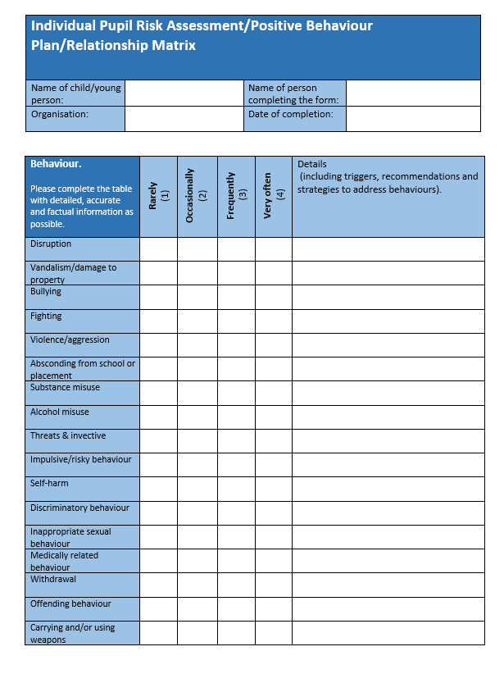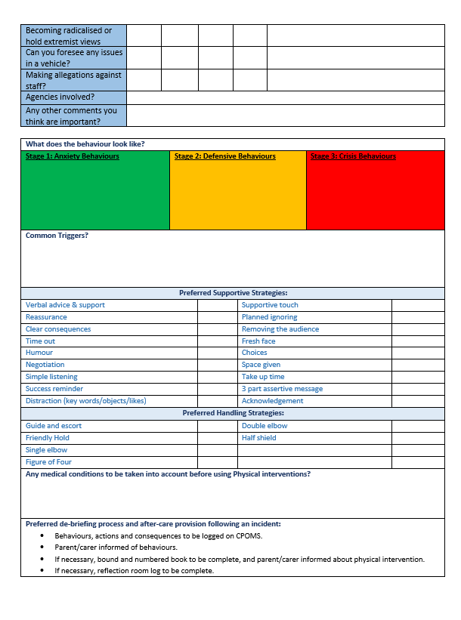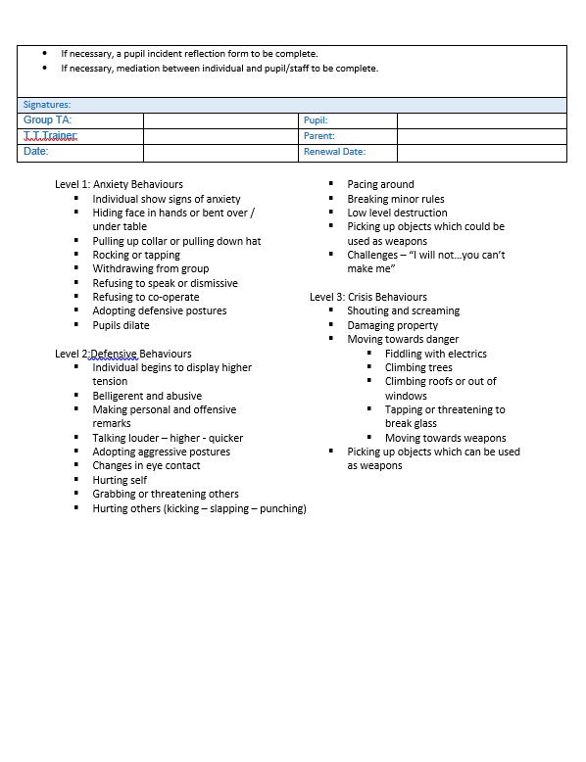 Appendix 1

