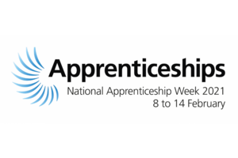

National Apprenticeship Week 2021

The week of 8 to 14 February 2021 is the 14th annual National Apprenticeship Week across England; a time to recognise and celebrate the success of thousands of apprentices across the country.

This year’s theme for the week is ‘Build the Future’, with the intention to encourage everyone to consider how apprenticeships can help individuals to develop the skills and knowledge required for a rewarding career, and employers to build a workforce with future ready skills.

There are currently around 7,000 apprenticeship opportunities available on the **[Find An Apprenticeship website](https://www.gov.uk/apply-apprenticeship" \t "_blank)**. Minister for Apprenticeships and Skills, Gillian Keegan said: “Apprenticeships are a fantastic way to learn while you earn. It’s been a tough year for everyone, but we want the theme for National Apprenticeship Week 2021 to be a springboard to look ahead to how apprenticeships can futureproof workforces and boost careers.”

Businesses, individuals and communities are being encouraged to get involved with the initiative and show how they celebrate apprenticeships over three key areas:

* **TRAIN** – Future proof your workforce or career though an apprenticeship.
* **RETAIN** – Apprentices gain the skills and knowledge your organisation needs, learn the values of your business and make impact. They allow you to build your future workforce and talent.
* **ACHIEVE** – Realise the business benefits and career progression available and how apprenticeships and traineeships can help you transform your future.

At Bishopton we want to ensure that you have all the support that you need during this week therefore we will be putting links onto the website on a daily basis for you to attend virtual events including Q and A with colleges, employers and apprentices.

The first of our links is from Middlesbrough College;



To celebrate National Apprenticeship Week, we are excited to host a Live Apprenticeship Q&A with some of our own apprentices! Come along to get all of your questions answered about what it's like to be an apprentice. Don't worry- you won't need to be on camera to take part in this!

Pre-register for the session here:

<https://bit.ly/2NU6OSo>

Good luck and stay safe