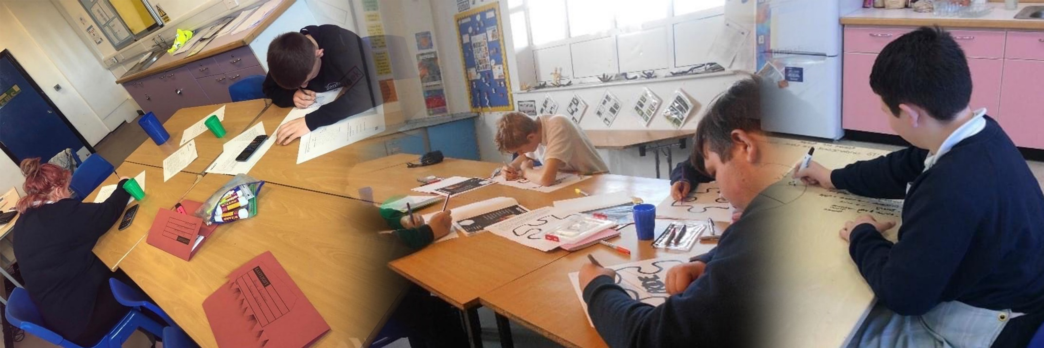

* Restructure complete with clarity of roles, responsibilities and CPD pathways identified and articulated.
* A culture of academic ambition throughout the whole school.
* Staff are a multi-skilled professional body of experts that can support local schools, offering a range of specialist services.
* Annual Bishopton Conference if well attended and received.
* Bishopton outreach services (Menu of Services) are utilised and support schools cross the authority.

**Our Aims and Beliefs**

A ‘Whole’istic approach

**COME WITH A PAST, ENJOY THE PRESENT, LEAVE WITH A FUTURE.**

**BISHOPTON SCHOOL DEVELOPMENT PLAN – STRATEGIC VISION 2020/24**

Investing in futures and life beyond Bishopton

* Sophisticated systems in place to establish, audit and monitor Extended Work Experience opportunities to enrich pupils’ timetable, provide valuable life/work experience and build relationships with potential future employers.
* Pupils leave us with a range of academic & vocational outcomes so they are competitive with their mainstream peers and NEET figures are low.
* Bishopton has two fully trained staff at level 4 and level 6 IAG and achieves the Careers Quality Mark and the Matrix Standard for IAG.
* Bishopton work with a wide range of external partners as part of a strong and stable Careers Programme.
* Apprenticeship opportunities for students are embedded.
* Parenting Support Programmes are a regular fixture on the school calendar, offering tailor made packages of support for parents/carers in promoting positive mental health, attendance, academic support and strategies for effective parenting.
* There are fully operational nurture models that are successful in engaging the most vulnerable pupils in the Borough, offering a highly individualised programme of both academic and therapeutic opportunities to ensure the best possible outcomes for pupils with specific needs.
* The school has achieved a Mental Health Award and IQM Flagship Award and has maintained the SMSC Award Beacon School Status. Other awards achieved reflect the school values and ambitions.
* The building has had a major redevelopment with clear multi-use zones that have been adapted to offer a range of curriculum pathways, including vocational pathways.
* Bishopton is a Beacon PRU serving as a dynamic hub, coordinating a network of PRU’s helping them develop confidence, proficiency and excellence in teaching, learning and assessment in both academic and vocational subjects and with mental health and wellbeing needs.
* There is a broad and balanced curriculum meeting a wider range of pupil’s needs and ambitions.
* Children leave with strong qualifications and clear post 16 pathways.

To establish clear post 16 pathways by developing strong links with colleges and universities.

To train and develop staff in school to offer Careers Information Advice and Guidance at level 4 and level 6.

To develop a database of Extended Work Experience opportunities, linking pupils with local employers.

To nurture and develop each and every pupil on an individual basis so that they can manage their emotions effectively.

To establish a nurture model for key stage 3 pupils to provide greater stability and consistency and to address their SEMH needs so that they can achieve the best outcomes both academically and vocationally.

To develop and embed Parenting Support Programmes to strengthen the work carried out in school to promote pupils’ SMSC, social, emotional and academic development.

To become a PRU Beacon of Excellence and teaching school.

To develop and design a building that is fit for purpose with dedicated learning zones to broaden the curriculum.

To deliver outstanding academic progress in a wide range of academic and vocational subjects.

To create internal specialist services e.g. Counsellors and Behaviour experts as well as academic subject specialists.

To embed mental health expertise within the school and create specialists on site.

**Objectives**

To develop the staff structure with clear career development pathways and progression to further upskill the workforce.

**Key Performance Indicators**

Developing Staff

Aiming for excellence