Dear parent/Carer,

Social media can be a wonderful addition to our lives but if used inappropriately it can be harmful to your children’s wellbeing or place them in dangerous situations.

Over the past week we have been made aware of online safety concerns linked specifically to social media platforms. We would like to remind all parents/carers that majority of social media sites have age restrictions in place to ensure children safety.

Using social media in an unacceptable manner: writing abusive messages aimed at others in their classes; sharing videos that are not appropriate for their age; posting unacceptable content and infringing copyright laws. Actions like this can result in serious consequences and we want all our pupils to continue to engage with technology but in a safe way.

Some recent concerns are:

A recent Facebook post has been causing concern for parents relating to YouTube kids and ‘Evil Santa’. The video allegedly features Santa telling the child to harm themselves in order to receive presents for Christmas and the more people they hurt the more gifts they will receive.

TikTok scams, where accounts are looking legitimate but are inappropriate videos and information.

On social media, there's a new type of influencer. But instead of promoting clothing lines and lifestyle products, they promote fraud.
They flash stacks of cash, hide their faces, and some even lure new recruits by selling guides on committing fraud.

ADVICE
Parents are advised to talk regularly with their children about their online presence and reassure them they can share anything with you no matter how delicate the nature is.
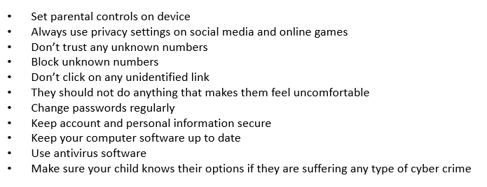
We recommend the following to help keep children safe online:
There are many online resources that can give some excellent advice on how to keep your child safe online:

www.getsafeonline.org
www.internetmatters.org
www.net-aware.org.uk
www.saferinternet.org.uk
www.ceop.police.uk

For more information, please contact Kirsty Walsh or Jemma Cruces k.walsh@tvc.ac.uk
j.cruces@tvc.ac.uk or on 01642 566369.

Yours Faithfully

Miss Walsh and Mrs Cruces

