9th September 2021

Dear Parent/Carer,

At Bishopton we believe in ensuring each child reaches their potential. Due to the COVID pandemic impacting on your child’s education over the last two academic years, we have decided to start offering our Y11 After School revision session in the Autumn term.

Students will be able to stay back each Wednesday, from Wednesday 15th September until 3.30pm to participate in revision in the subject area of their choice.

Please note that if your child attends this, they will need to make their own way home or be collected.

If you want your child to attend, please fill in and return the permission slip below.

If you require any further information, please contact school and speak with Mrs Cooling Assessment and Data Lead.

Kind regards,
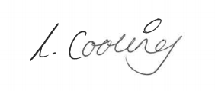

Mrs Laura Cooling
Teacher and Assessment and Data Lead

Please return this slip to Bishopton PRU

Name of child: ………………………………………………………………….

I do / do not want my child to attend the Wednesday revision sessions, at Bishopton, from 2.30 - 3.30pm.

If you wish your child to attend, please indicate below which method of transport you wish your child to return home on:

My child will make their own way home / be collected / get the bus.

Signature of parent/carer: …………………………………………………………………………………………………………

