8th December 2021
Re: End of Term
Dear Parents and Carers,
As we approach the end of the Autumn term, we wish to thank you for your continued support with ensuring your child fulfils their full potential whilst at Bishopton.
The pupils have shown tremendous grit and resilience after over 18 months of disruption to their lives, caused by the pandemic. We are extremely proud of them and enjoy continuing to share and shape their journey throughout education.
Achievements:
We are delighted to inform you that after an incredibly busy year, we have been successful in achieving Flagship Status of the Inclusion Quality Mark Award. The Inclusion Quality Mark is awarded to schools who show a truly inclusive ethos around the education they deliver. We are one of only four PRUs in the country to achieve this status. Thank you to you and your child for making this possible. Please visit our website to read more about our achievements.
Key dates:
The last day of term is Friday, 17th December 2021 and school will close at 1.30 pm. If your child has a taxi, it will be taking them home at this time.
If anyone has any queries about this, please call the school to inform us.
Due to the ongoing concerns around the Coronavirus pandemic and the emergent of a new variant, we are continuing to encourage home testing and the 12-15year old vaccination programme.
On Tuesday 4th January the school will be open to pupils between 2pm and 3.30pm for on-site testing. Please indicate to your child’s tutor, or to the school Health and Safety Lead, if you plan to be tested in school.
The first day of the new term is Wednesday, 5th January 2021, and we look forward to seeing all pupils then.
We are looking forward to a successful spring term one.

Below are a few key dates to remember, for the coming months:

Date | Activity
Monday 3rd January | New Year Bank Holiday
Tuesday 4th January | PD day
Monday 31st January | PD day
Friday 18th February | End of Half Term
Monday 28th February | Return to School

We would like to wish you and your family a restful break over the holiday period and a prosperous New Year.
Yours faithfully
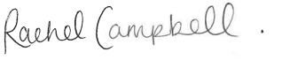
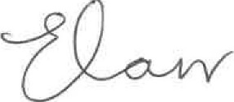
Emily Carr
Headteacher

