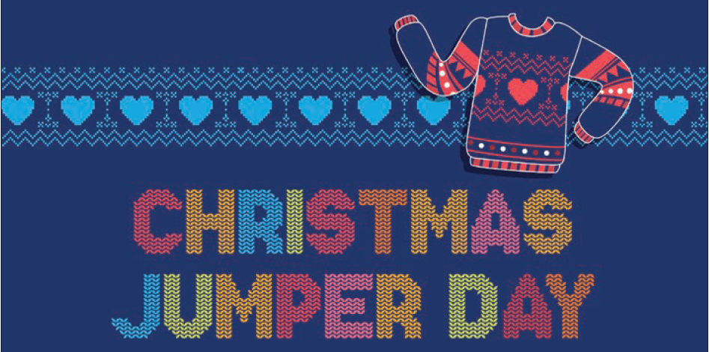
Dear Parents and Carers,
Here at Bishopton we believe in the importance of not only our pupils but also our parents and carers and encourage parents and carers involvement in our School. As you may know, we are having our Christmas jumper day and Christmas dinner on the 17^{th of} December, the last day of the term.
As a thank you for your continued support of our school, we would love you to join us for Christmas dinner. This will be a great opportunity for you to speak to staff informally and enjoy some festive treats.
Please arrive at our main reception for 12 pm, dinner will be served at approximately 12.30 pm.
At 1.30 pm you will be able to take your son or daughter home or if you prefer, they will go home in their taxi.

RETURN SLIP

If you could let us know whether you would like to attend by returning the attached slip or by phone so that we can order your food.

I will/will not be attending the Christmas dinner on the 17th December

Parent/Carer’s Name________________________
Name of child ________________________
Number of persons attending ____

