July 2022

Dear Parents and Carers,

Firstly, thank you for your support as we continue learning to live with COVID. Here are the latest government guidelines that we are following if your child has a positive COVID test.

Children under 18 years should stay at home for 3 days from the positive test.

Full details can be found on the following links.

If we can be of any help or support, please do not hesitate to contact the school.

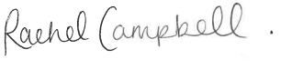
Emily Carr/Rachel Campbell
Co-Headteachers

https://www.gov.uk/coronavirus-taxon/health-and-wellbeing
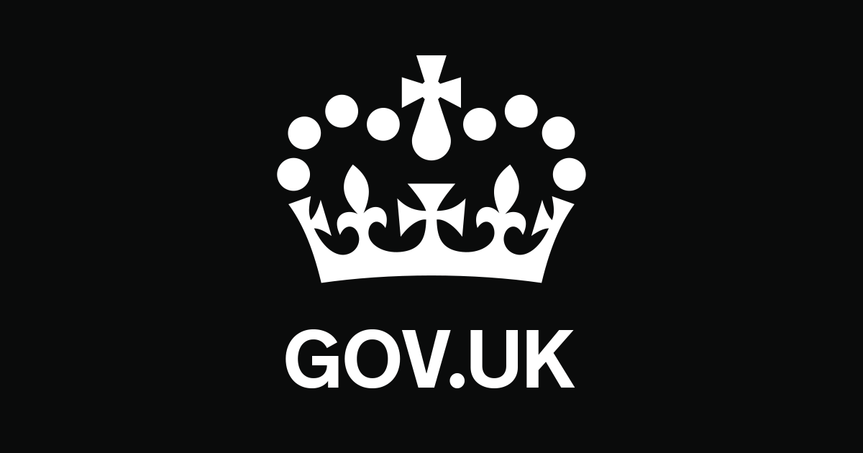 | Coronavirus (COVID-19): guidance and support  Find information on coronavirus, including guidance and support.  www.gov.uk

