Date: August 2022

Re: New entrance and upcoming building work

Dear Parents/Carers.

We hope you and your family have had a restful summer and that your child feels prepared on returning to Bishopton.

We are pleased to remind our school community of the regeneration project, which is set to take place at Bishopton PRU, with a start date of this September.

Our two separate buildings will be linked by a new extension, creating one school that will improve our communication and accessibility between the two buildings. This will also enable two, clearly visible entrances to the school.

The extension will also create space for a hall, kitchen, staff room and changing space. The design will make use of the existing space, creating one cohesive building and giving a much-needed update to what we currently have.

The result will be a bright and modern new area which will be accessible for all. Teaching areas for construction skills and other specialist areas will also be included in the development.
The build will include improvement to our outdoor space, creating secure new areas for KS3 and KS4 children.

We are so pleased that our pupils will finally have a building that is fit for purpose and of a high standard!

Due to the building work commencing soon, all staff and pupils will be based in the larger of the two buildings, at the back of the site, from 1st September. We will be using the dining room entrance way as our main entrance for the first half term whilst the side entrance is made suitable.

Please see the attached images of the entrance way for your reference when you visit our school.

Please be aware that as building work takes place, students will be restricted to certain areas of the school. We will continue to keep you updated throughout this exciting process. If you have any questions or queries, please do not hesitate to contact either head teacher for a meeting.

Many thanks.

Emily Carr and Rachel Campbell
Co-Headteachers
Bishopton PRU

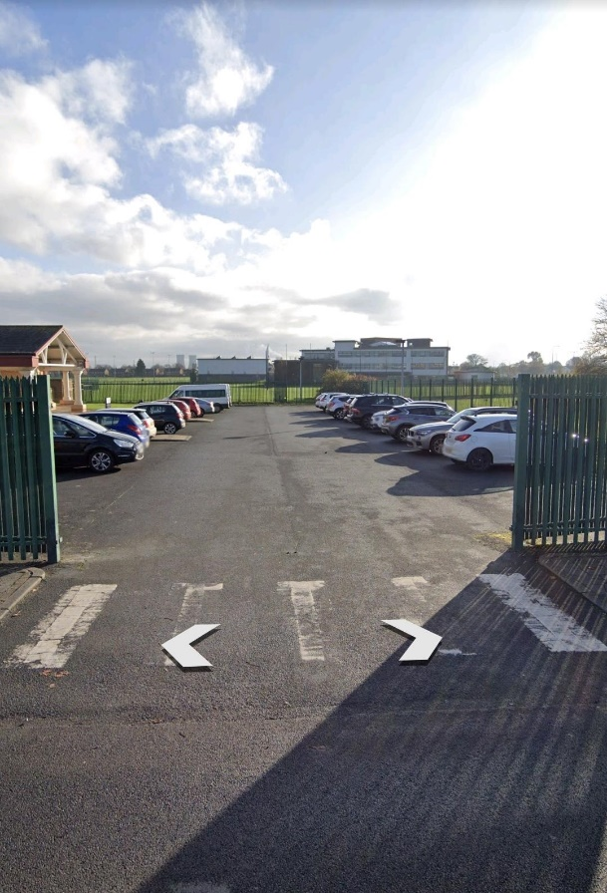
This entrance way will no longer be in use. The car park will be partially open for staff and visitors.

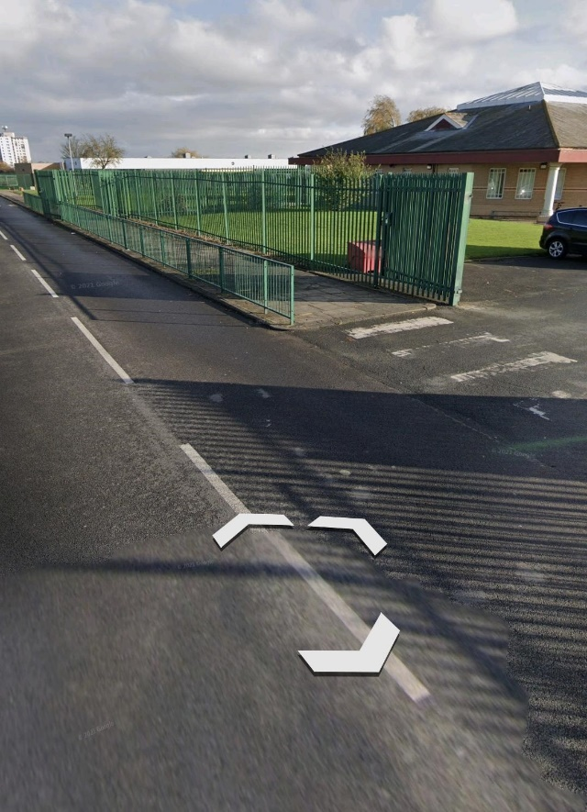
Once you have parked, this is the pathway to walk down to get to the main entrance.

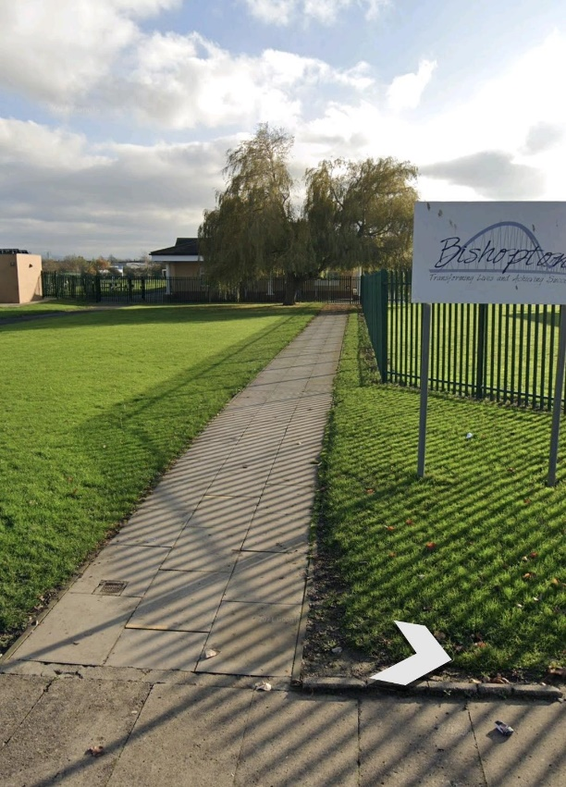
This is the current pupil entrance way. This will now be the entrance to the school for all pupils, staff, parents/carers and stakeholders.

