November 2022

Dear Parents and Carers,

Bishopton Local Governing Body – Notice for Parents and Carers

We are writing to inform you that there is a vacancy on the Bishopton Governing Body for a Parent Governor, and we would like to invite parents and carers to consider this role. We believe, this is an excellent opportunity for you to contribute to the decisions made by the Governing Body, as well as to build strong links between the Governing Body and our School and support Bishopton in our goal of becoming an ‘outstanding’ School.

Nomination procedure

The document attached explains this process in detail and includes the nomination form, which you are to complete if you would like to apply.

Appointment arrangements

Where more than one nomination is received an election will be required and ballot papers, together with further details, will be issued. Where one nomination is received the nominee will be appointed as Parent Governor; if no nominations are received, it will be the responsibility of the Bishopton Governing Body to appoint a parent or carer to the vacancy.

All appointments will be subject to a disclosure (DBS) check.

It is usual to have 2 separate parents or carers of this school to support your nomination but if you have difficulty in finding two parents to support your application, please contact Mrs Carr or Mrs Campbell, on telephone number 01642 566369.

You may also wish to provide a personal statement to support your application.

We hope that you will consider this roll and look forward to your nominations.

Please note completed nomination forms must be returned to the Co-Headteachers of the school by the closing date of Monday, 12th December 2022 at 12 pm.

Best wishes,

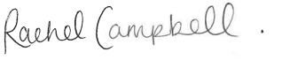
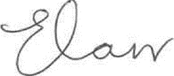

Emily Carr/Rachel Campbell
Co-Headteachers
Bishopton PRU

