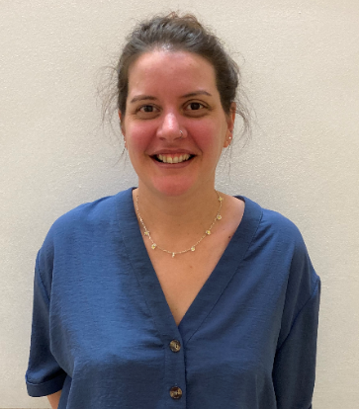 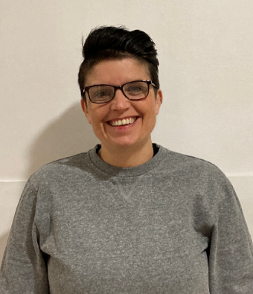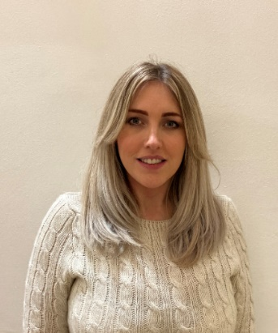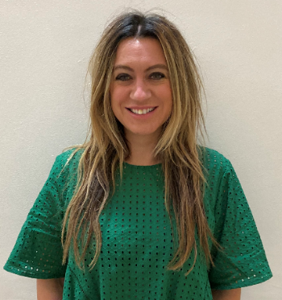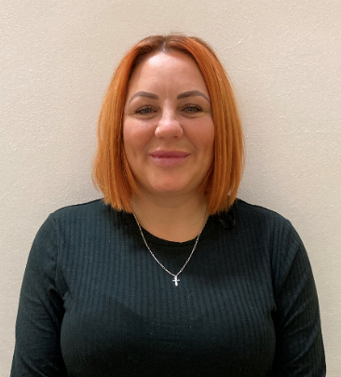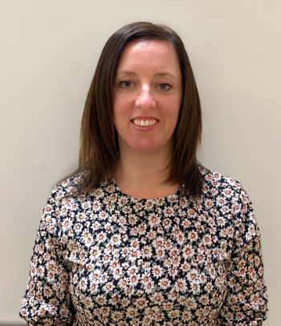

Need someone to talk to?

Miss Walsh

KS4 Lead

Never feel scared to speak out.

Mrs Hall

Admissions/Access and Inclusion officer



Speak to us, we’re here to listen to you at any time during the day.

Mrs Lorna McClean

Chair of Governors and Safeguarding Governor.

Mrs Thompson

Assistant Headteacher

SENCO and Designated Teacher

Deputy Safeguarding Lead

We want you to enjoy school and feel safe and happy at home.

There is always someone that you can talk to.

Remember that you are not alone.

If you are worried about coming into school, let us know.

Mrs Carr

Headteacher

Designated Safeguarding Lead

Mrs Campbell Headteacher Designated Safeguarding Lead

Mrs Dack

Outreach Officer

Mrs Davies

Parent and Attendance Support Officer

We are committed to safeguarding all children in our care, which is paramount in all that we practice and deliver

**YOUR**

**Safeguarding Team**