Careers Education, Information, Advice and Guidance (CEIAG) Policy

Date: | January 2023
Date approved by Governing Body:
Signature of Chair of Governing Body:
To be reviewed: | January 2024

This policy articulates Bishopton’s Careers Educational Information Advice and Guidance. This policy should be read in conjunction with the PSHE, SMSC, Teaching and Learning, Equal Opportunities and British Values policies.
Introduction

Bishopton has a statutory duty of care to secure independent careers guidance for all year 7 to 11 pupils (Education Act 2011/Careers Guidance and Access for Education and Training Providers 2018). Underpinned by the Gatsby Benchmarks, our CASTLE values, SMSC Strategy our vision is as follows:

“We believe every child should leave our school prepared for life in an ever-changing modern society. We therefore provide the academic rigour supported by quality teaching and learning to develop every young person’s values, skills and behaviours that they will need to progress and succeed in all aspects of life”

The statutory duty requires schools to ensure that all registered pupils at the school are provided with independent* careers guidance.
This advice is:

- Presented in an impartial* manner
- Includes information on the range of education or training options, including apprenticeships and other vocational pathways
- The guidance given promote the best interests of the pupils to whom it is given.

*Independent is defined as external to the school.
* Impartial is defined as showing no bias or favouritism towards a particular education or work option.

Aims of CEIAG (Careers Education, Information, Advice and Guidance)
- Provide good quality independent careers advice to pupils which inspires and motivates them to fulfil their potential.
- Provide personal advice and guidance which is in the best interests of and meets the needs of all pupils.
- Be based on the Gatsby Benchmarks for Good Careers Guidance.
- Contribute to raising of pupil achievement by encouraging pupils to develop high aspirations and consider a broad and ambitious range of careers.
- Provide opportunities to work in partnership with employers, training providers, local colleges and others.
- Provide opportunities to inspire pupils through real-life contact with the world of work.
- Develop enterprise and employability skills including skills for self-employment.
- Support inclusion, challenge stereotyping and promote equality of opportunity.
- Encourage pupils to see career development as a life-long process.
- Develop pupils’ skills and knowledge of careers including career management skills and knowledge of the local labour market (Local Labour Market Information LMI).
- Ensure pupils are aware of the full range of academic and technical routes available at each transition point so that pupils have the necessary knowledge to make successful transitions.
- Provide opportunities for meaningful encounters with employees, employers, further and higher education and experiences of workplaces.
- Support social mobility by improving opportunities for all pupils, especially those from disadvantaged backgrounds and those with special educational needs and/or disabilities.
- Be embedded into all subjects across the curriculum including PSHE
Commitment
Career guidance can include employers’ talks, inspirational speakers, mentoring, talks from colleges and other further educational establishments, apprenticeship providers and universities as well as access to online information. External speakers are coordinated by the Careers Lead in Bishopton and supported by key members of staff.
Independent advice & guidance in Bishopton is currently offered to year 7 – 10 by a level 6 qualified member of staff. Bishopton has an agreement in place for Youth Directions who work with our pupils from year 11. The advisers are suitably qualified and bound by the CDI code of ethics. It is presented in an impartial manner, showing no favouritism towards a particular industry, provider or institution. The guidance covers a full range of post 16 options and is pupil focused based in their needs, wants and aspirations.
Bishopton is committed to providing a stable and structured programme of education, advice and guidance. Based on the Gatsby Benchmarks for Good Career Guidance this is differentiated to suit the needs of each pupil including pupils with SEND and other complex needs. Bishopton Career Programme can be found in Appendix A.
Each pupil is entitled to:
- Independent and impartial careers guidance
- Access to external sources of information on the full range of education and training options
- A stable programme of advice and guidance delivered by individuals with appropriate skills, experience and qualifications
- Opportunities to engage with a range of employers, education and training providers, covering the full range of academic and technical routes available at each transition point
- At least one meaningful encounter with an employee or employer each academic year
- Have access to good quality LMI and be supported to use this data to inform their decisions
- At least one careers interview by the age of 16 with a Careers Adviser
- At least one experience of a workplace by the age of 16
Bishopton has been recognised as delivering good quality CEAIG and has achieved the Quality in Careers Standard in December 2017 and remains committed to keeping that quality mark which is currently being re-assessed and will be completed by the end of 2022.

Pupil Entitlement - Core Offer & Progression Framework
Key Stage 3 Provision:
- Subject areas promoting careers within curriculum areas
- Access to impartial advice and guidance sessions with internal staff
- Access to online packages
- External visits
- Internal talks
- CASTLE Days – Aspirations and Self-Belief
- Access to careers and IAG enrichment and extra-curricular activities and events
- Careers Events
- Specific careers focused lessons in PSHE
By the end of KS3 will have achieved the following measurable outcomes:
- Pupils can articulate verbally and in writing their strengths and how this aligns to with 2-3 employability characteristics
- Pupils can list at least one career pathway linked to subjects they work towards as part of their curriculum.
- Pupils will be able to talk about their local LMI and be able to identify careers based on financial outputs.
- Pupils will have begun to look at financial management.
- Pupils will be able to identify skills needed to run a successful enterprise initiative and link it to some of their own skill sets.
- Pupils will be engaged in target setting, particularly for KS4 options.
- Pupils will have had some meaningful encounters with employers.
Key Stage 4 Provision:
- Subject areas promoting careers within curriculum areas
- Experience of a workplace
- A careers themed COPE Programme
- Apprenticeship Provider talks
- Access to impartial advice and guidance sessions with Youth Direction
- Access to online packages e.g., National Careers Service and Grofar
- External visits
- Internal talks
- CASTLE Days – Aspirations and Self-Belief
- Access to careers and IAG enrichment and extra-curricular activities and events
- Careers Events
- Dedicated Employability lessons with the opportunities to achieve certificates in Food Hygiene, First Aid at Work and ICT.
- Dedicated Careers Curriculum aligned to the CDI Framework for Careers, Employability and Enterprise

By the end of KS4 pupils will have:
- Enhanced their career management and employability skills
- Used online packages and other sources of information, advice and guidance to investigate and explore progression routes
- The opportunity to experience the world of work through possible work experience and workplace visits.
- Be given direct access to employers, colleges and training providers
- Be given independent impartial external one to one advice on post 16 destinations
- Developed an Employability Folder which includes a CV, personal statement and evidence of a mock interview with feedback.
- Produce a challenging but realistic plan by relating their abilities, attributes and achievements to the goals they have set themselves.
External Partnerships
Bishopton works effectively with a range of external stakeholders including vocational provision and has developed several partners to offer:
- Careers events
- Career talks
- Mentoring
- Workplace visits
- FE and HE institutions
- Apprenticeship visits and talks
- Inspirational Speakers including Alumni
- Enterprise activities
- Youth Direction
- Careers & Enterprise Company
- Job Centre+
Bishopton provides opportunities for informing pupils about technical educational qualifications or apprenticeships and has a published statement setting out arrangements for Provider Access published on our website.
https://bishopton.tvc.ac.uk/careers/
Bishopton actively promoted parent/carer involvement through CEIAG events, new letters, the website and consultation evenings.
Parent/Carer Involvement
Parent/carer consultation and feedback allows parents/carers to share their views and provide valuable input in the development of school policy and careers education, information, advice and guidance. We value and welcome parents/carers feedback and as such offer unlimited opportunities for consultation with no end date. Please email s.johnson@bishopton.tv.ac.uk responses will be reviewed regularly and taken into account when the policy is reviewed annually. A copy of the Parent/Carer Feedback Form can be found in the appendix.
Equal Opportunities
In support of the school’s Equal Opportunities Policy the careers education and guidance will ensure that:
- Lessons cover Equality of Opportunity.
- Carefully selected nonbiased or stereotypical posters and other media material.
- Pupils are encouraged to prepare to support themselves financially.
- Pupils are encouraged to consider all options including non-traditional careers/roles.
- There is an avoidance of the use of gender and gender specific job titles.
- Offer as free a choice as possible for Extended Work Experience.
- Boys and girls have equal opportunities to speak, offer opinions and answer questions in lessons.
- All pupils have equal access to information.
School Website
The school has a Careers page on its website which has a number of links to organisations that can offer impartial advice and support with a range of different areas e.g., interview techniques, CV writing and online training to support young people into making choices. Parents and carers will be encouraged to access this webpage to support their child and perhaps find some useful information themselves.
Provider Access
Statutory Requirements

Schools are required to ensure that there is an opportunity for a range of education and training providers to access students in years 8 to 13 for the purposes of informing them about approved technical education, qualifications or apprenticeships.
Schools must provide a minimum of 6 encounters with technical education or training providers to all pupils in years 8 to 13 (see more detail in section 2.1 below).

Schools must also have a policy statement that outlines the circumstances in which education and training providers will be given access to these students.

This is outlined in section 42B of the Education Act 1997 the Skills and Post 16 Education Act 2022 and on page 43 of guidance from the Department for Education DfE on Careers Guidance and Access for education and training providers.

This policy shows how our school complies with these requirements.

The 6 encounters schools must offer to all students in years 8 to 13

Through the Skills and Post-16 Education Act 2022 we have made further provision as to the number of provider encounters that schools must offer and when, and set new parameters around the duration and content of each encounter.
All maintained schools and academies must provide six encounters with a provider of technical education or apprenticeships for year 8 to 13 pupils. We have timed these six meetings to inform consideration of post-14, post-16 and post-18 options and progression to the next stage of education or training.
As a minimum, schools must offer:
- Two encounters for pupils during the ‘first key phase’ (year 8 or 9) that are mandatory for all pupils to attend, to take place any time during year 8 or between 1 September and 28 February during year 9.
- Two encounters for pupils during the ‘second key phase’ (year 10 or 11) that are mandatory for all pupils to attend, to take place any time during year 10 or between 1 September and 28 February during year 11.
- Two encounters for pupils during the ‘third key phase’ (year 12 or 13) that are mandatory for the school to put on but optional for pupils to attend, to take place any time during year 12 or between 1 September and 28 February during year 13
These encounters must happen for a reasonable period during the standard school day. Schools can continue to provide complementary experiences but encounters outside of school hours won’t count towards these requirements.
Schools must ask each provider to provide the following as a minimum:
- Information about the provider and the approved qualifications or apprenticeships they offer
- Information about what careers those qualifications and apprenticeships can lead to
- What learning or training with the provider is like
- Answers to any questions from pupils
Bishopton will ensure that every provider encounter covers these elements and will seek to check presentations or handouts intended for the day will be subject to an audit before the encounter.
Meaningful Provider Encounters
Bishopton is committed to providing meaningful encounters to all pupils.
1 encounter is defined as 1 meeting/session between pupils and 1 provider. Meaningful live online encounter engagement is also an option at Bishopton.
Student Entitlement

All students in years 8 -13 at Bishopton are entitled to:

- Find out about technical education qualifications and apprenticeships opportunities, as part of a careers programme which provides information on the full range of education and training options available at each transition point.
- Hear from a range of local providers about the opportunities they offer, including technical education and apprenticeships – through activities, events, assemblies and group discussions and taster sessions.
- Understand how to make applications for the full range of academic and technical courses.

The school is committed to providing access to providers of technical education qualifications and apprenticeship opportunities. A full provider access statement is available on the school website:

https://bishopton.tvc.ac.uk/careers/
CPD
Training needs are identified through Performance Management and through CEAIG based audits of need. CPD is offered to relevant staff as they arise. Information from CPD sessions is disseminated to staff through weekly team meetings. Staff attend networking events locally and nationally.
Responsibility for promoting the highest quality learning environment and creating impressive displays lies with the whole school community. It requires professionalism (based on Teachers Standards and Performance Management) from teachers and staff in the school and in return expects learners to understand the part they play in the process so that they can take responsibility for their own learning.
Roles & Responsibilities
All Bishopton staff have a responsibility for CEIAG through their roles within the school.
Key roles and responsibilities include:
- The Governing Body in defining and agreeing the principles underlying the school policy and in monitoring and reviewing its application. The Governing Body Lead for Careers is Lesley Graham
- The Co-Headteachers in framing the school policy and, with other members of the Senior Leadership Team, organising support for the implementation of the policy and the monitoring of the school environment.
- The Careers Lead Sophie Johnson and Careers Team in ensuring the provision for CEIAG is well planned and delivered and monitored.
- Teachers in observing the Teachers Standards and ensuring they are fulfilling their professional roles and responsibilities.
- All staff in ensuring consistent application of the policy.
Monitoring and Evaluation
- Bishopton’s progress towards the Gatsby Benchmarks is evaluated using the online Compass+ Tool this is carried out on a termly basis and informs the CEIAG Strategic Action Plan.
- Feedback from pupils and all key stakeholders are obtained and subject to scrutiny, they are analysed by the careers lead with actions fed back to whole school in team meetings.
- The effectiveness of Bishopton’s CEIAG if reflected in the number of pupils who successfully transition into post 16 destinations and remain in education, training and or employment including self-employment. Destination Data is collated approx. every 6 weeks and tracks the past 3 years leavers, this is fed back to the Co-Headteachers and Governing Body.
- The Partnership Agreement with Youth Direction is reviewed termly, and Youth Direction provide 6 weekly reports and updates regarding pupils.
- Quality of teaching, learning and assessment is monitored as part of the school’s internal Quality Assurance Framework undertaken by the designated middle and senior leaders and on occasion School Improvement colleagues from the Trust.
- When reviewing the programme, the School Development Plan is used to ensure that the CEIAG is fully supporting whole school vision, ethos, values and objectives.
- CEIAG policy is reviewed annually and ratified by the Governing Body.
UNICEF - UNCRC
The UN Convention of the Rights of the Child sets out human rights of every person under 18 and applies to every child without discrimination, whatever their ethnicity, gender, religion, language, abilities or any other status, whatever they think or say, whatever their family background (Article 2).
Articles directly relating to this policy are:
Article 2 (Non-discrimination)
Article 12 (Respect the views of the child)
Article 13 (Freedom of expression)
Article 17 (Access to information from the media)
Article 28 (Right to education)
Article 29 (Goals of education)
Article 31 (Leisure, play and culture)

Core Careers Programme
Appendix A
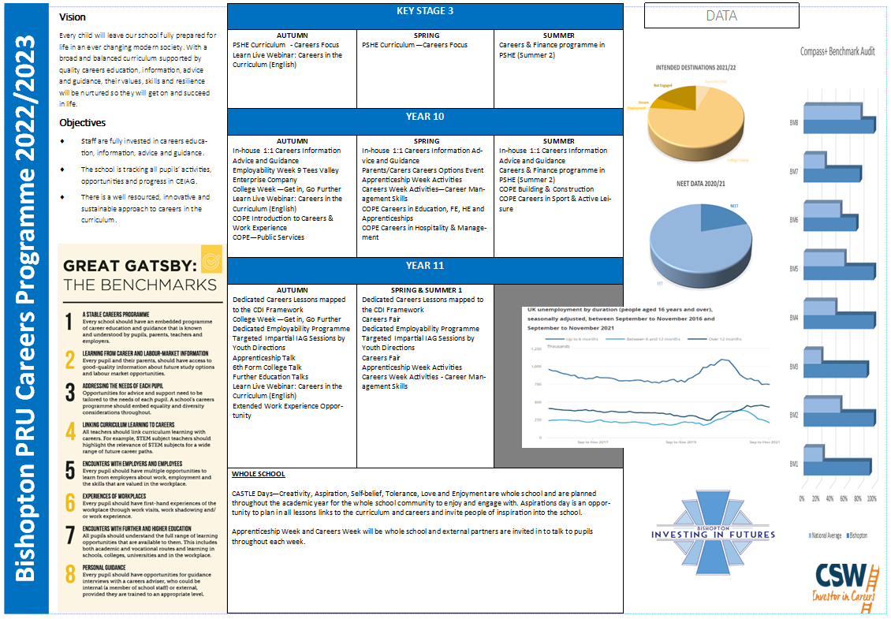

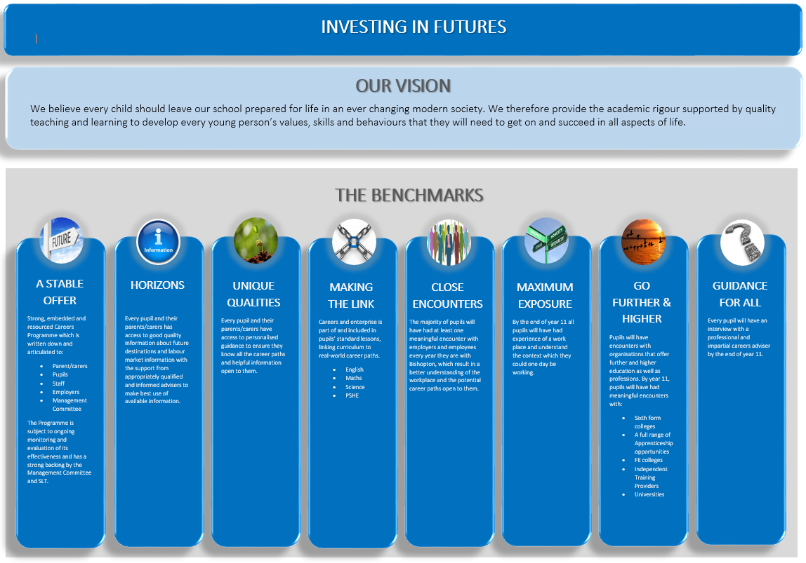
Appendix B
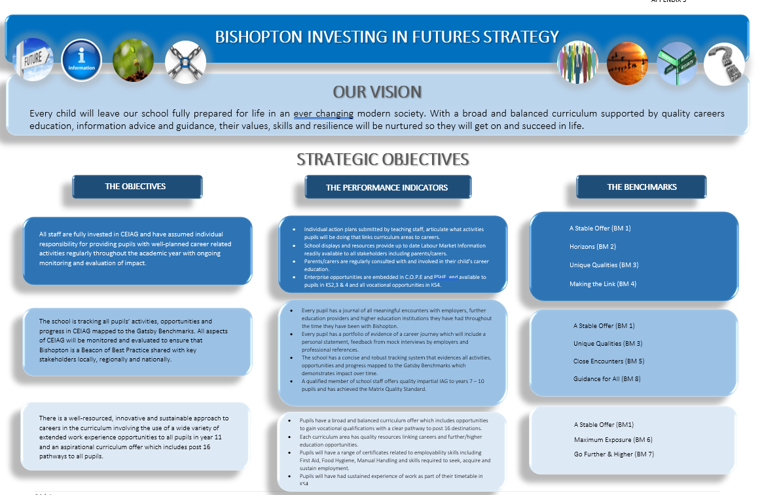
Appendix C

