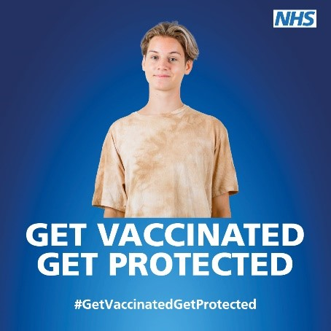

All secondary school children in year 9 will be eligible for a second dose Human Papilloma Virus vaccine (HPV).
If your child has not had their first dose in year 8, please follow the link and complete the consent form.

The School Age Immunisation Service will be visiting your child’s school on 25/4/23 to deliver the vaccine.
Your child will not receive this vaccine without a valid consent form.
Access the consent link here: https://www.hdftsais.co.uk/
School code: HD111521

If you have any problems with completing the online consent, please contact the Immunisations Consent Team on 0300 0032554

Find out more: https://www.nhs.uk

#GetVaccinatedGetProtected

